**BRIGADA APP**

**USER MANUAL**

Prepared by : Charles Kurt H. Caber

Team : UMTC-Visayan

1. **APP FIRST INTERFACE**
2. After you installed the app. Open the app and it will show you the splash screen and a permission for location you must **ALLOW** the permission.

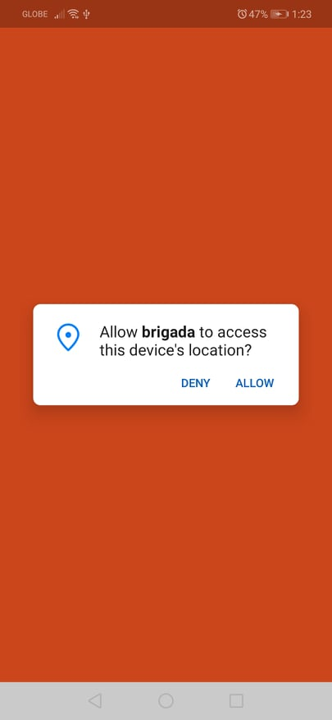

1. After the splashscreen the app will redirect you to the login screen.

In the login screen you will see the form for email and password.

But we don’t have an account yet so we need to register.

Tap the **SIGN UP** text to register and it will redirect you to sign up as page.

***SELECT IF YOU WANT A SCHOOL OR VOLUNTEER ACCOUNT.***

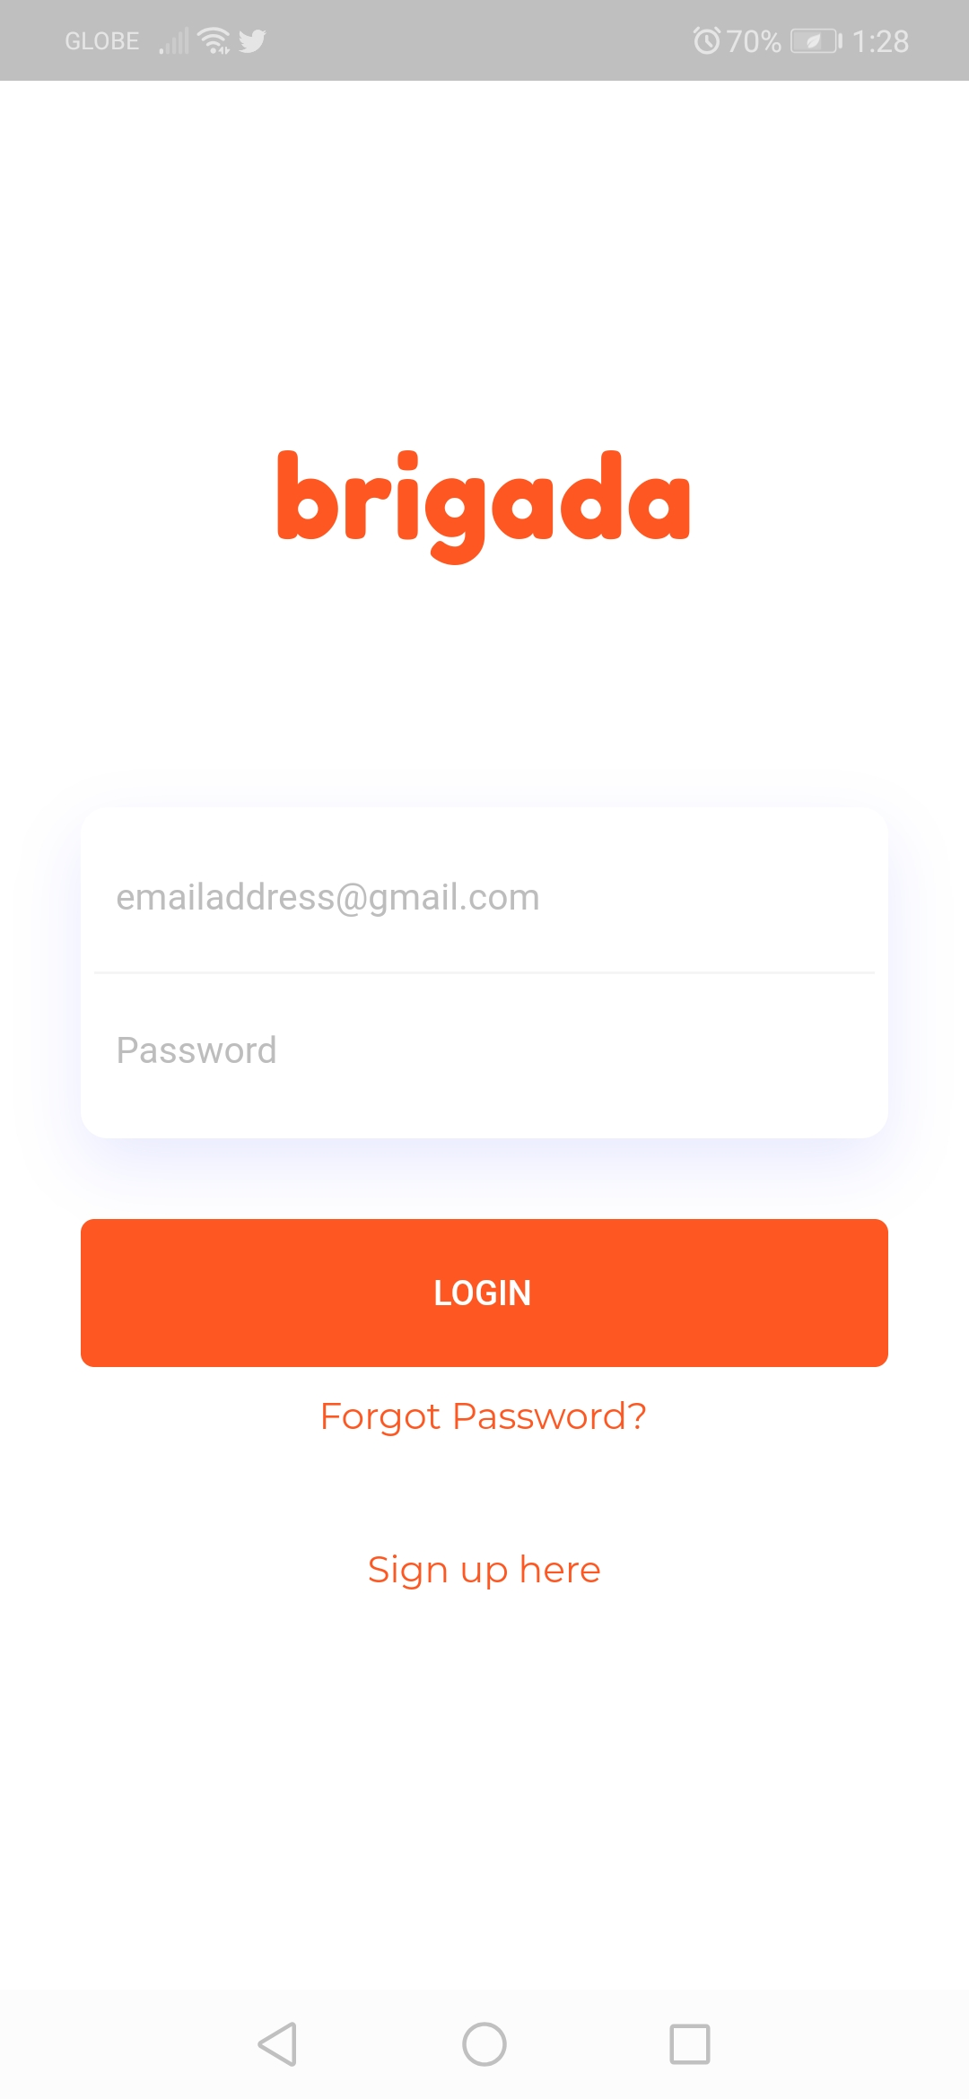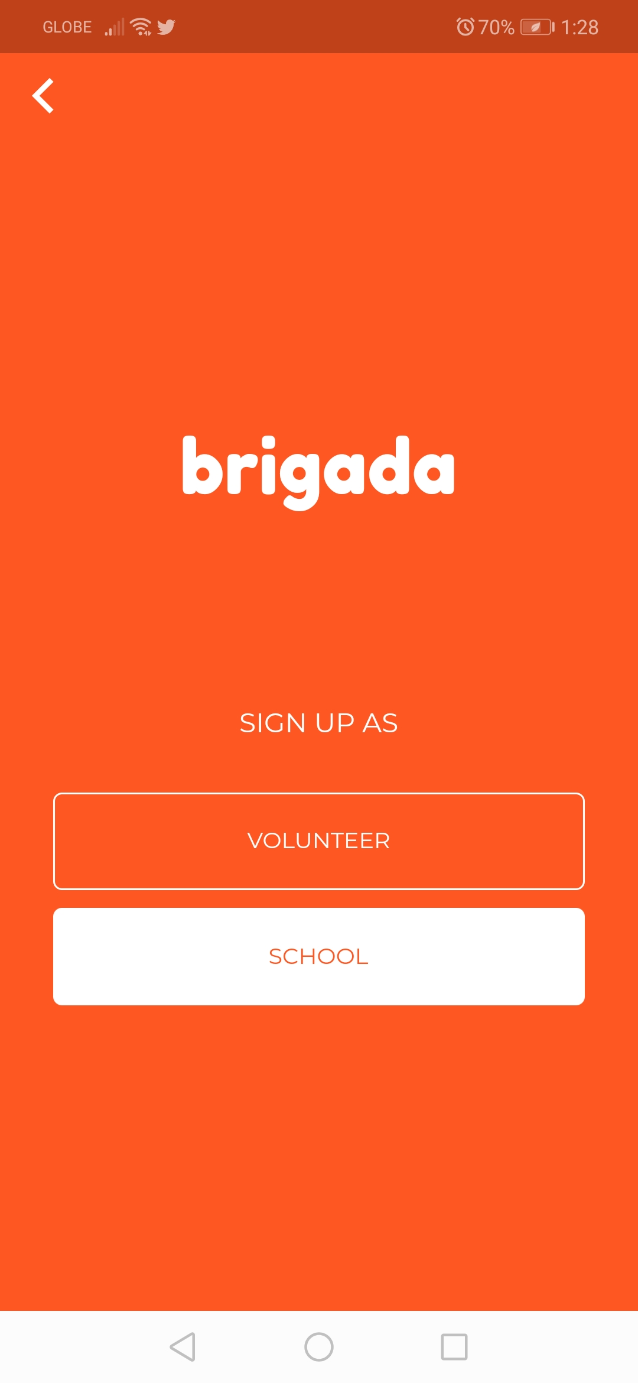

1. **REGISTRATION FOR SCHOOL**

***REGISTER AS SCHOOL***

1. After tapping the SCHOOL button on the sign up as page there are fields that you need to fill up.

First the **School Name**,

Second the **Address** before tapping the go button you must click first the search button to direct the on the inputted address

Last is the **Final registration** where you can register the email and password of your account.

Optional * I suggest email must have an active account on gmail or Google Account. **For forgot password and Reports.**

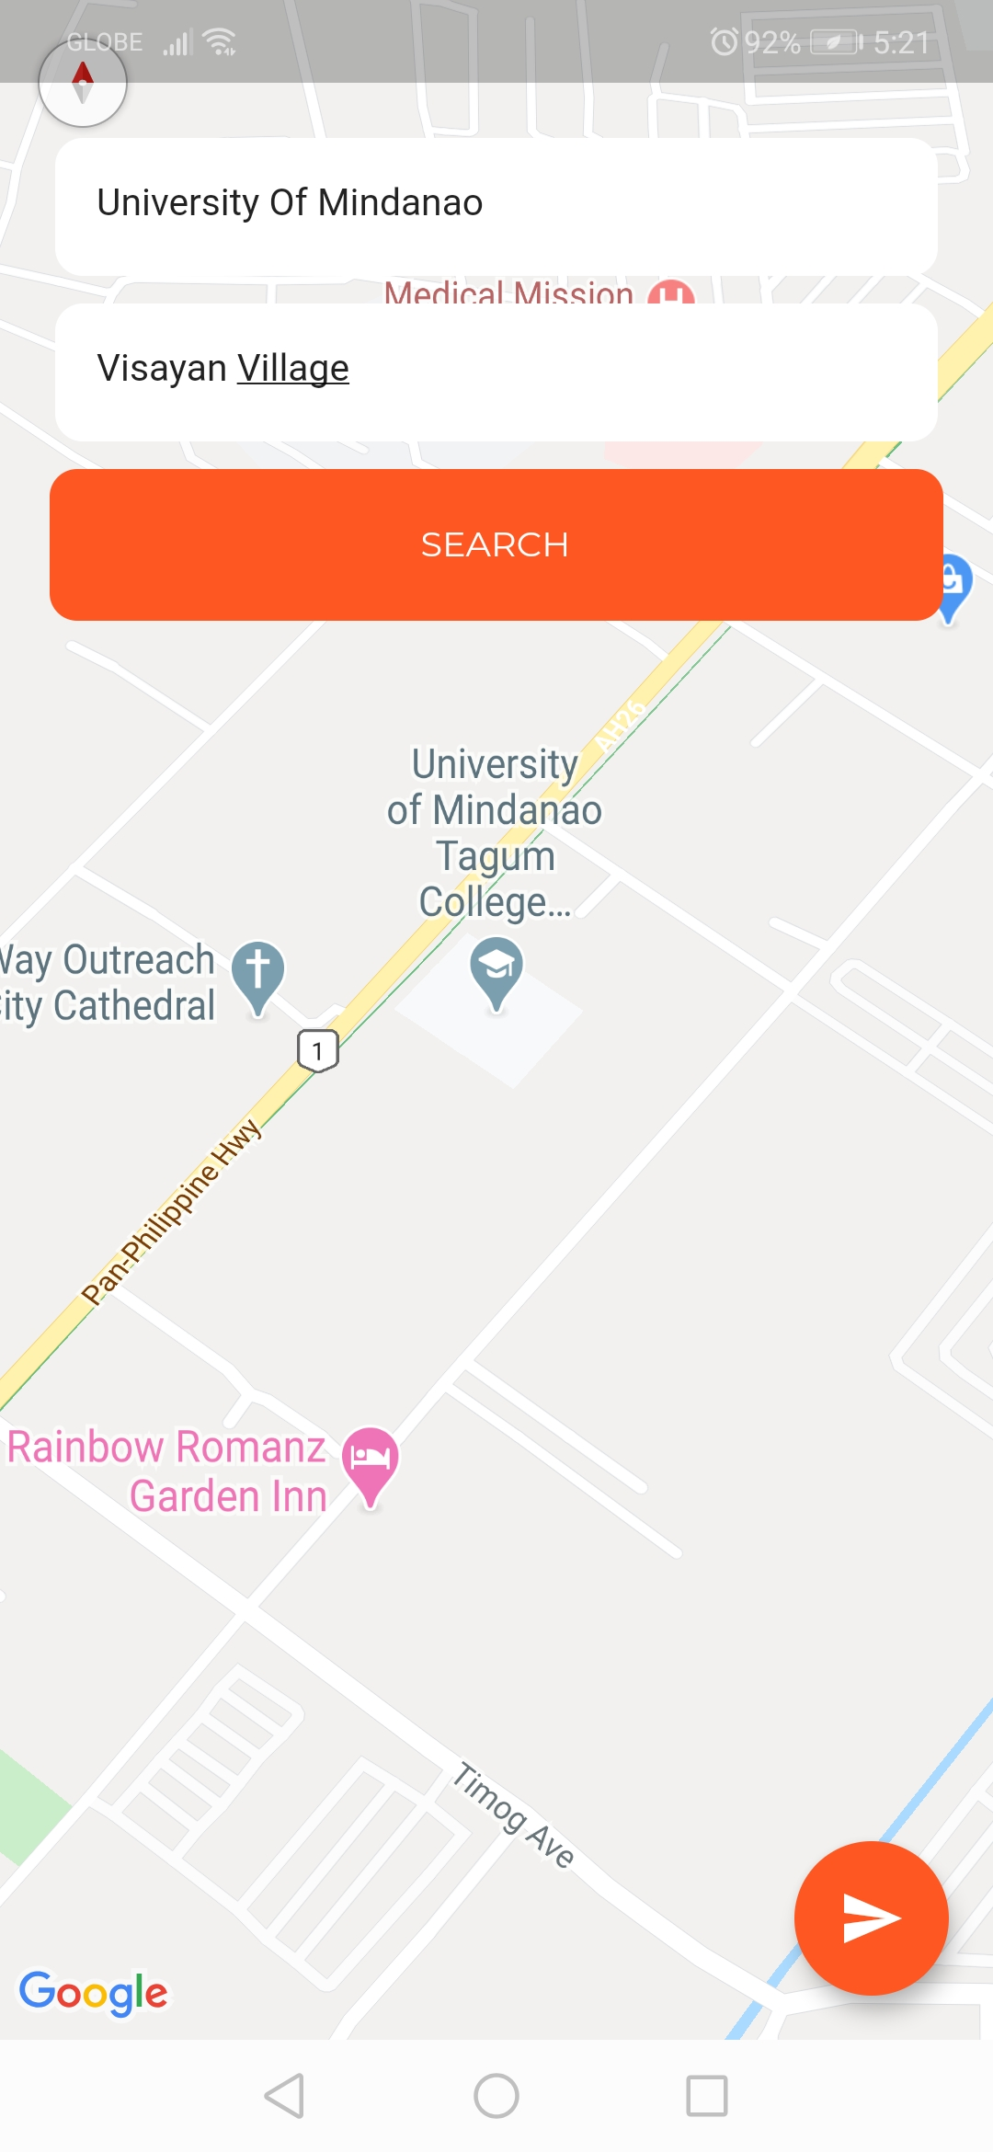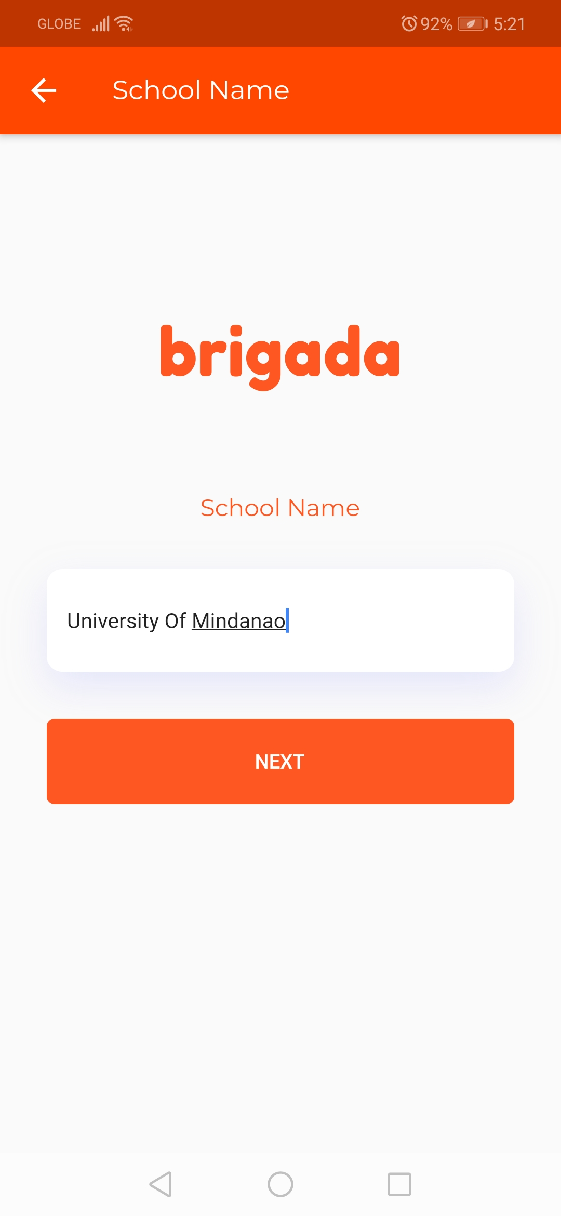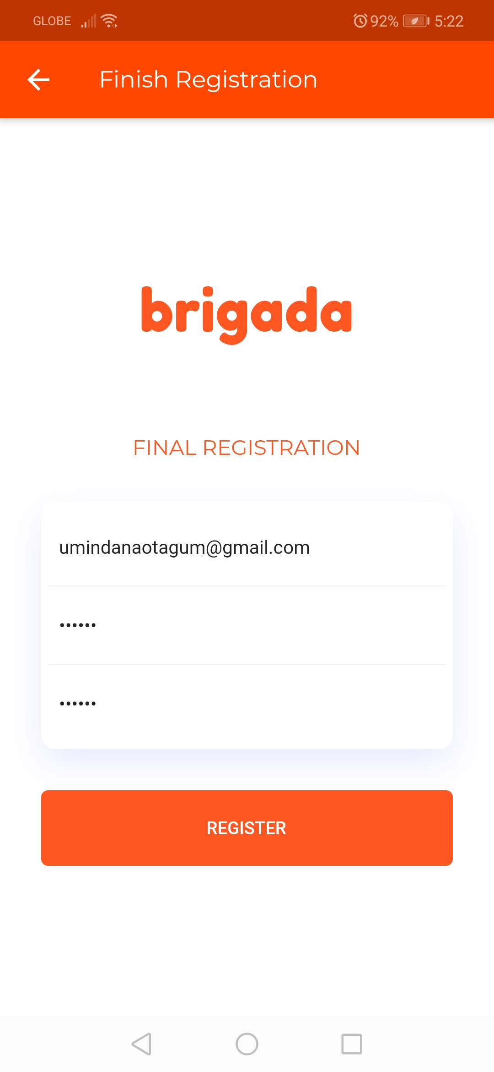

***AFTER CREATING SCHOOL ACCOUNT***

LOGIN YOUR ACCOUNT

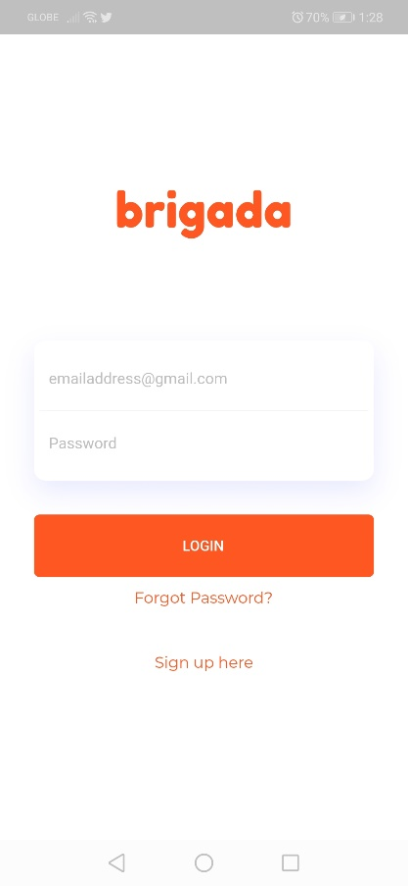

umindanaotagum@gmail.com

******

1. **SCHOOL INTERFACE AND FUNCTIONS**
2. The left photo is the home screen of the school account.

In order for us to add a request we need to tap the + button on the bottom right of the screen.

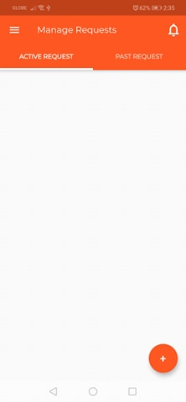

1. After tapping the + button. You will be redirected to add request functions.

First the **request title** screen where you can add a title on your request,

Second is the **request details** screen for request details,

Third is the **date and time** of the request **(default: current date and time)**,

And last you will see the **full details of your request** and you must upload **1 primary photo** and **3 other photos** in order for the volunteer to see the photo of why you need a volunteer.

***Note * You must allow the permission for gallery.***

Tap here to change time

Tap here to change date

Tap here to add photo

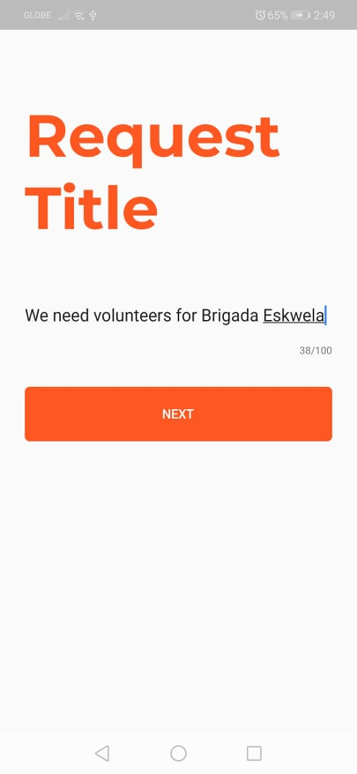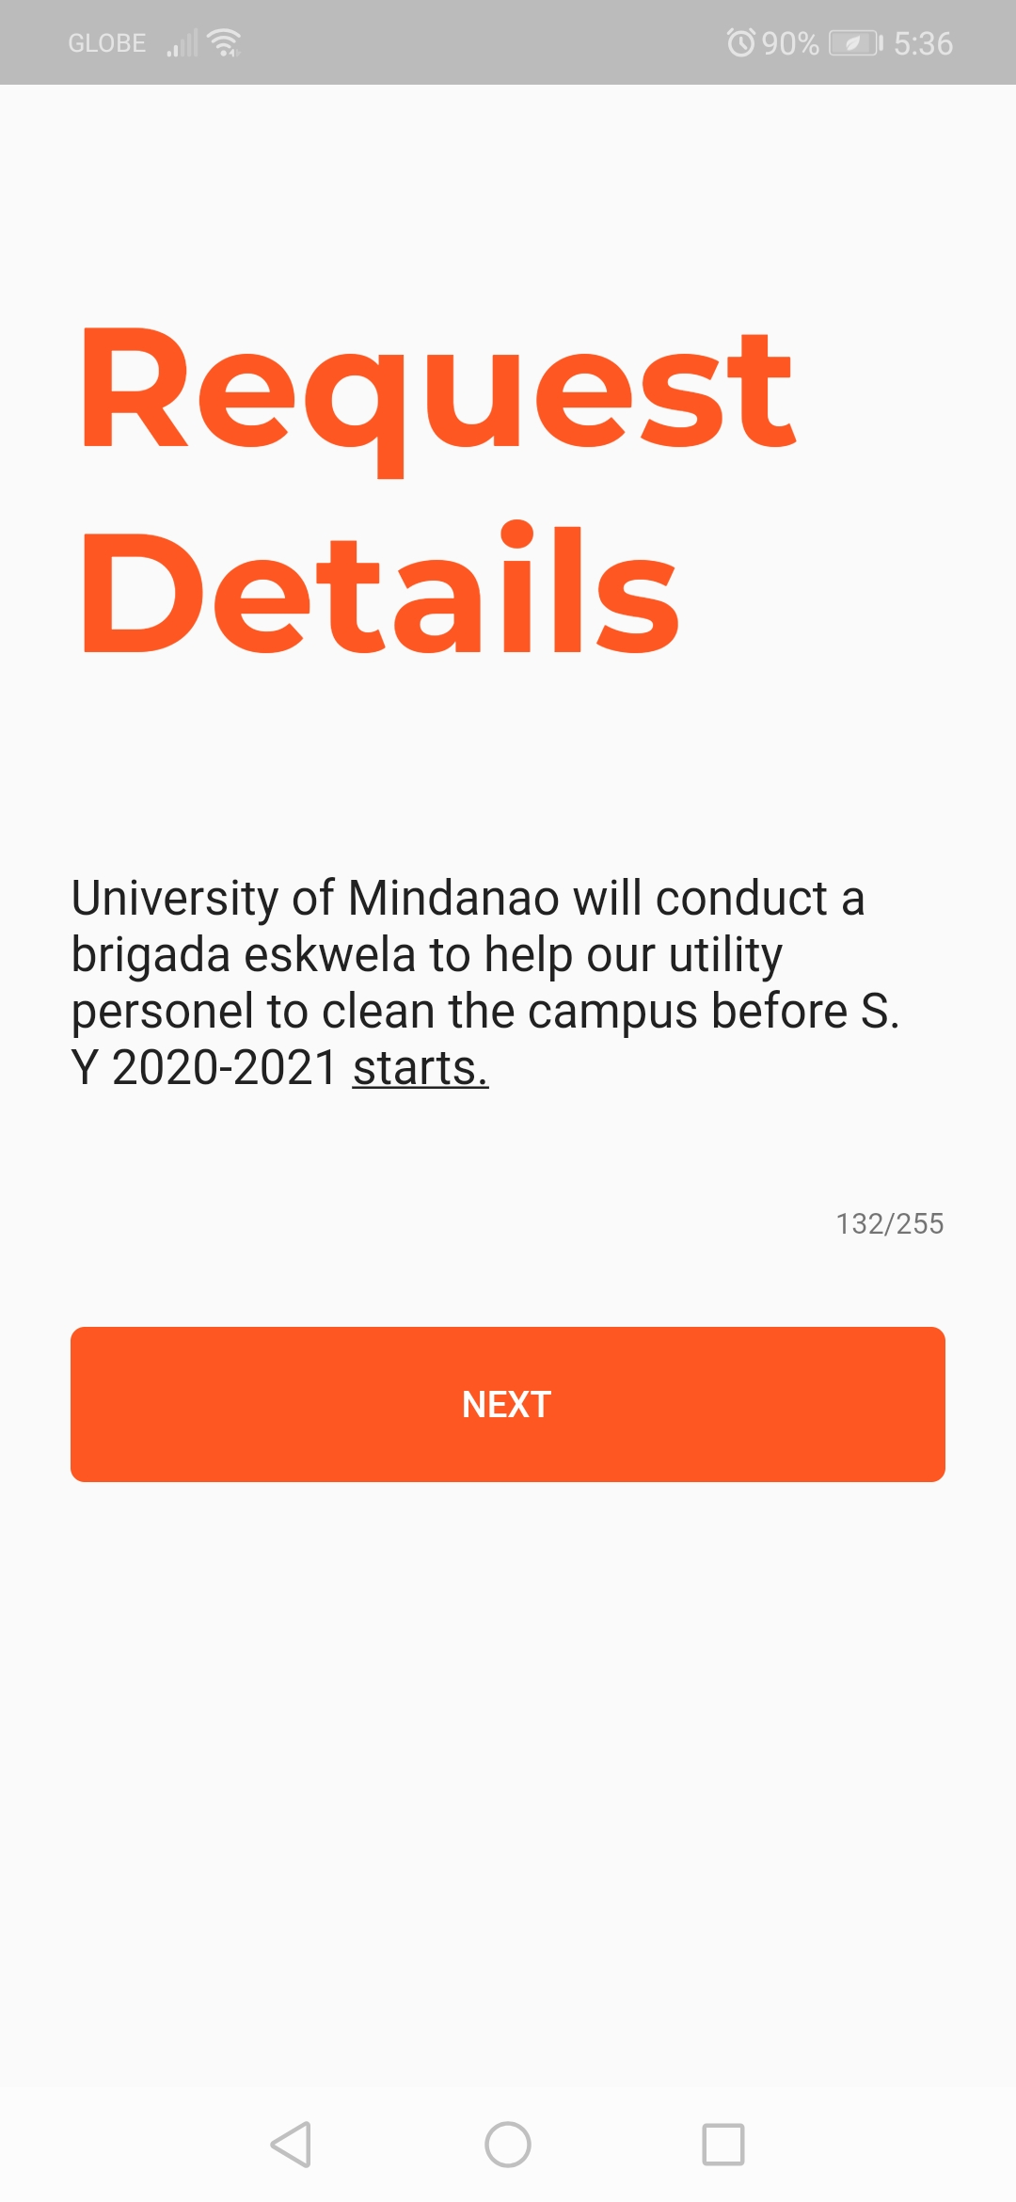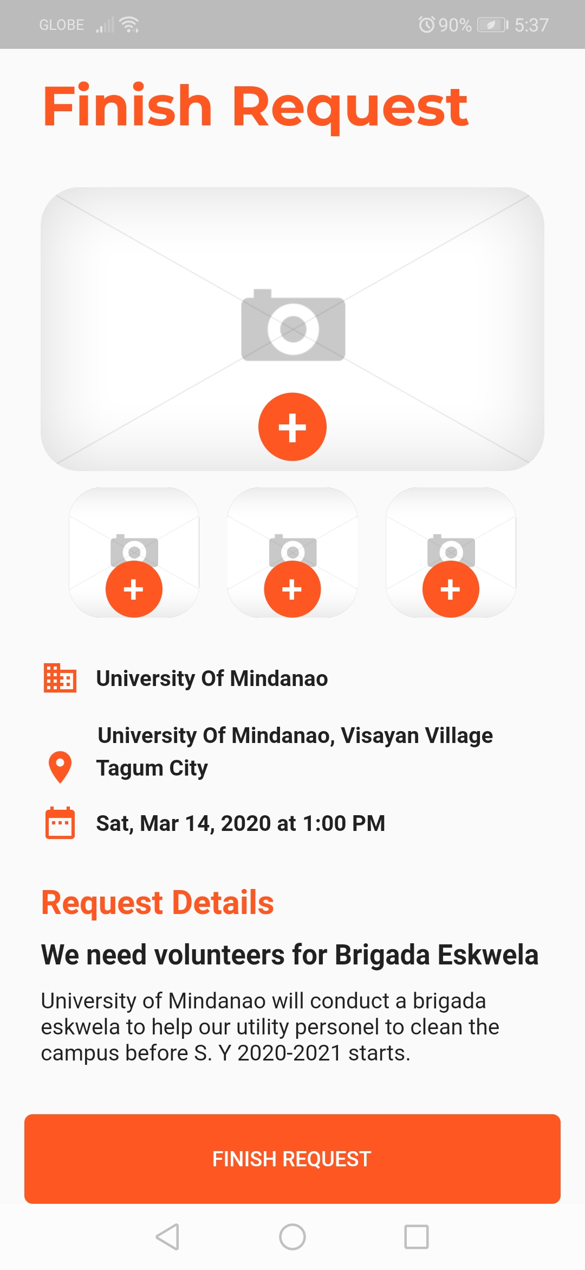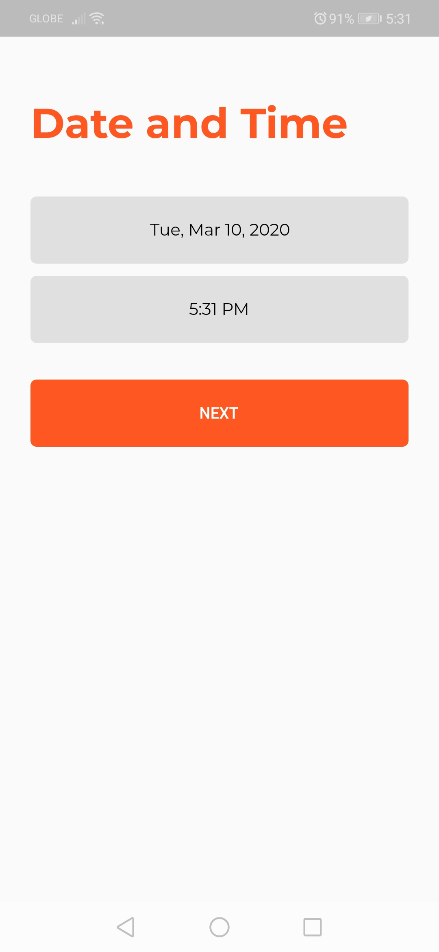

After adding the photos tap the finish request button and wait till the loading finish.

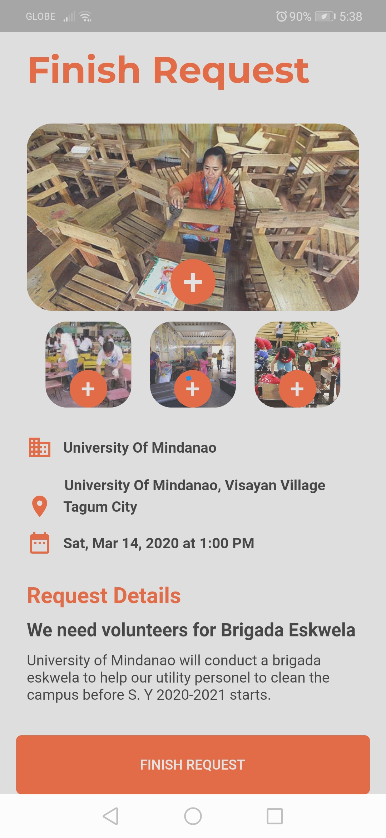

After the loading finishes it will automatically redirected you to the school home screen.

Tap the item on list of active request and it will show you the details of request.

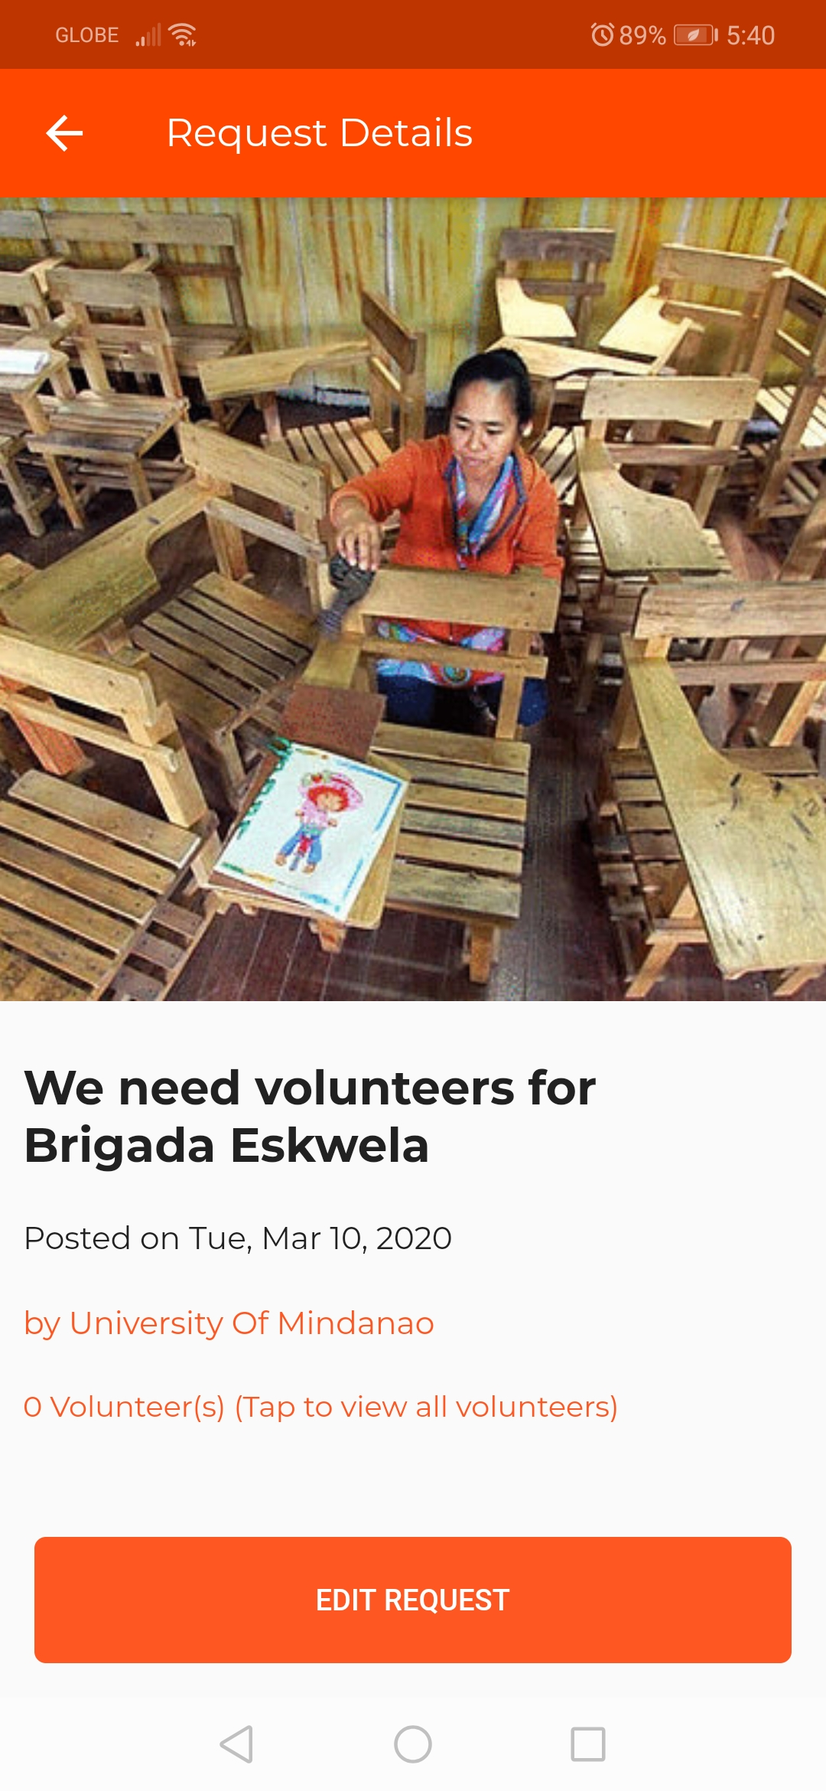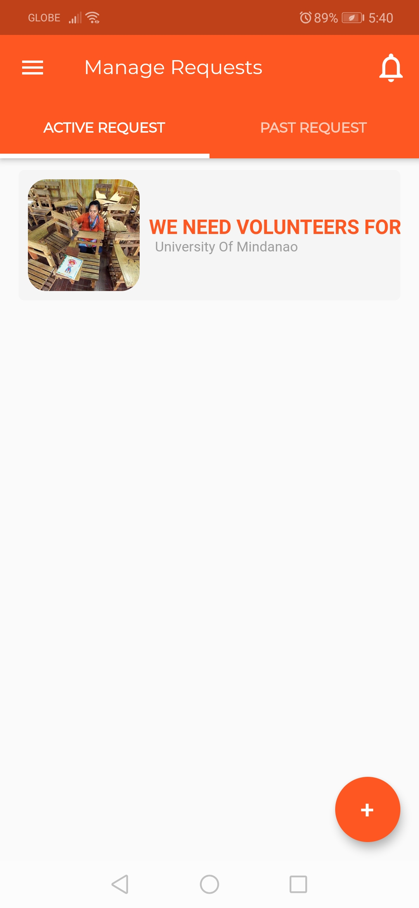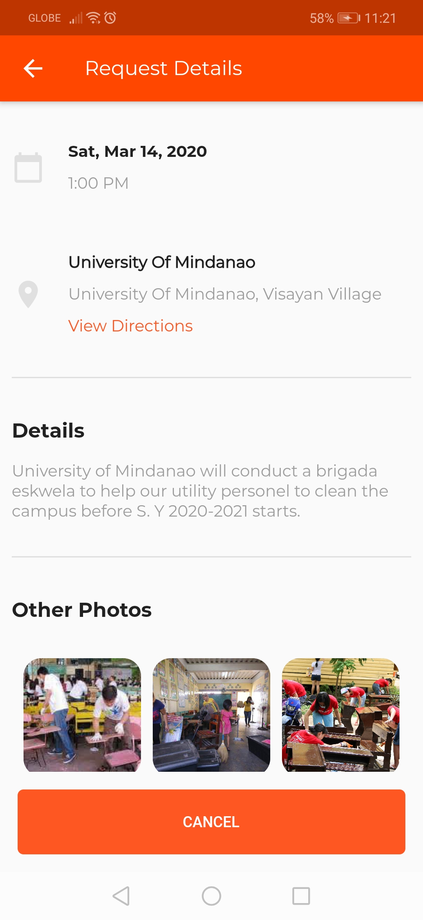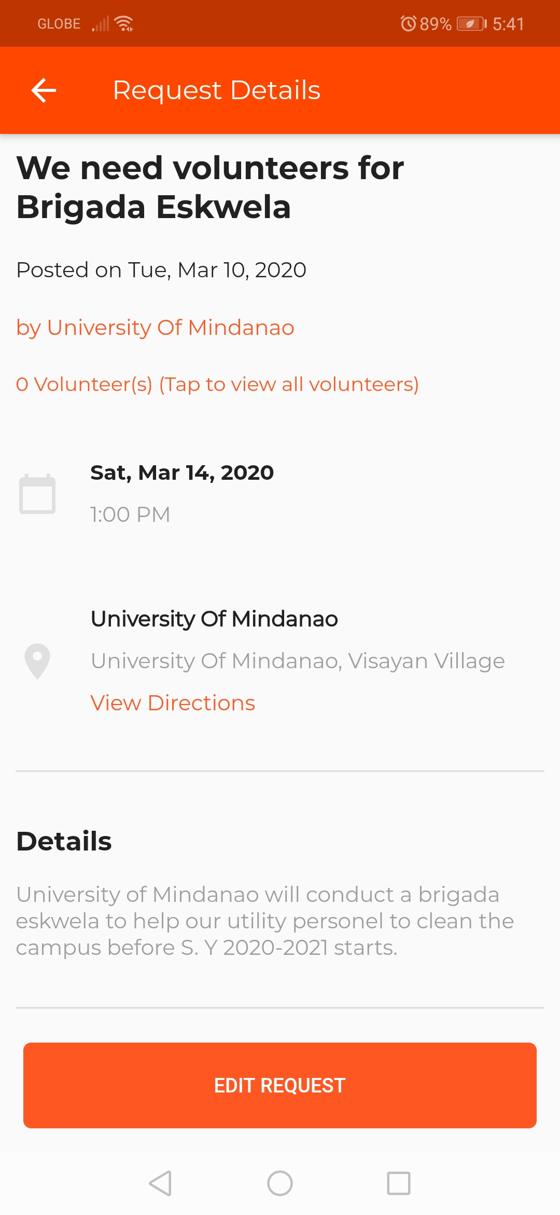

Tap the view directions to open the google map for you to see the school direction.

Tap the photo to view the photo full screen.

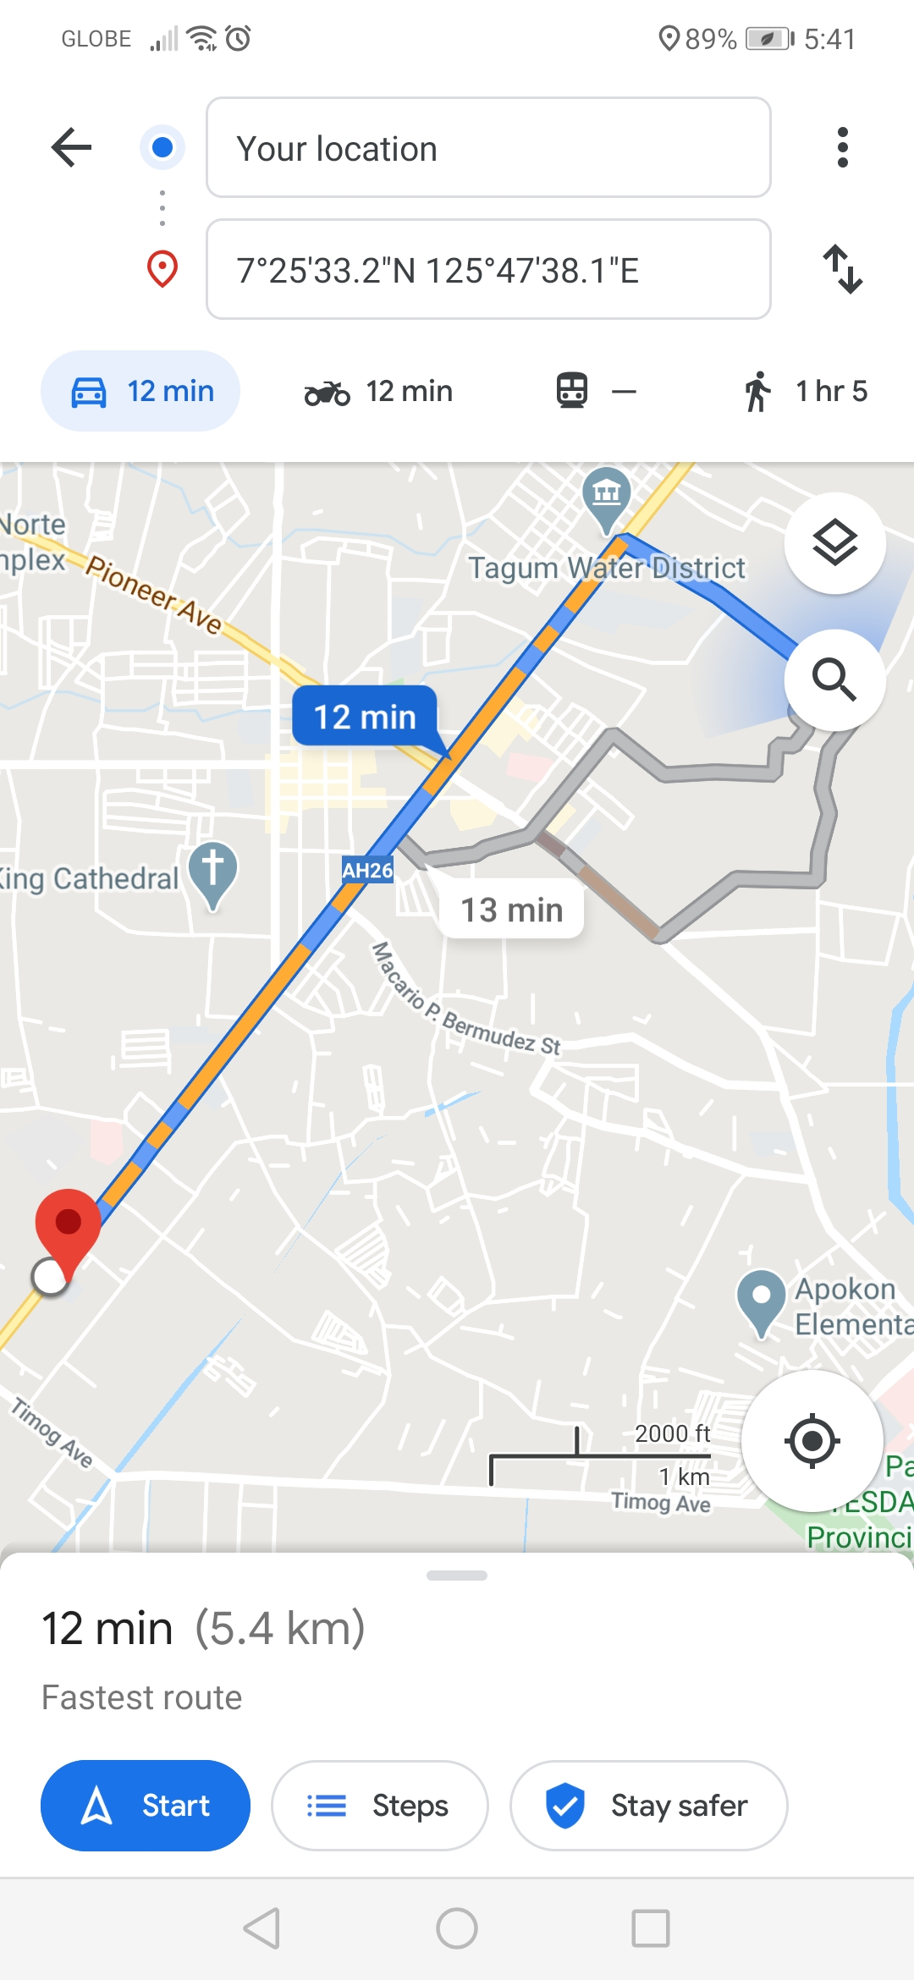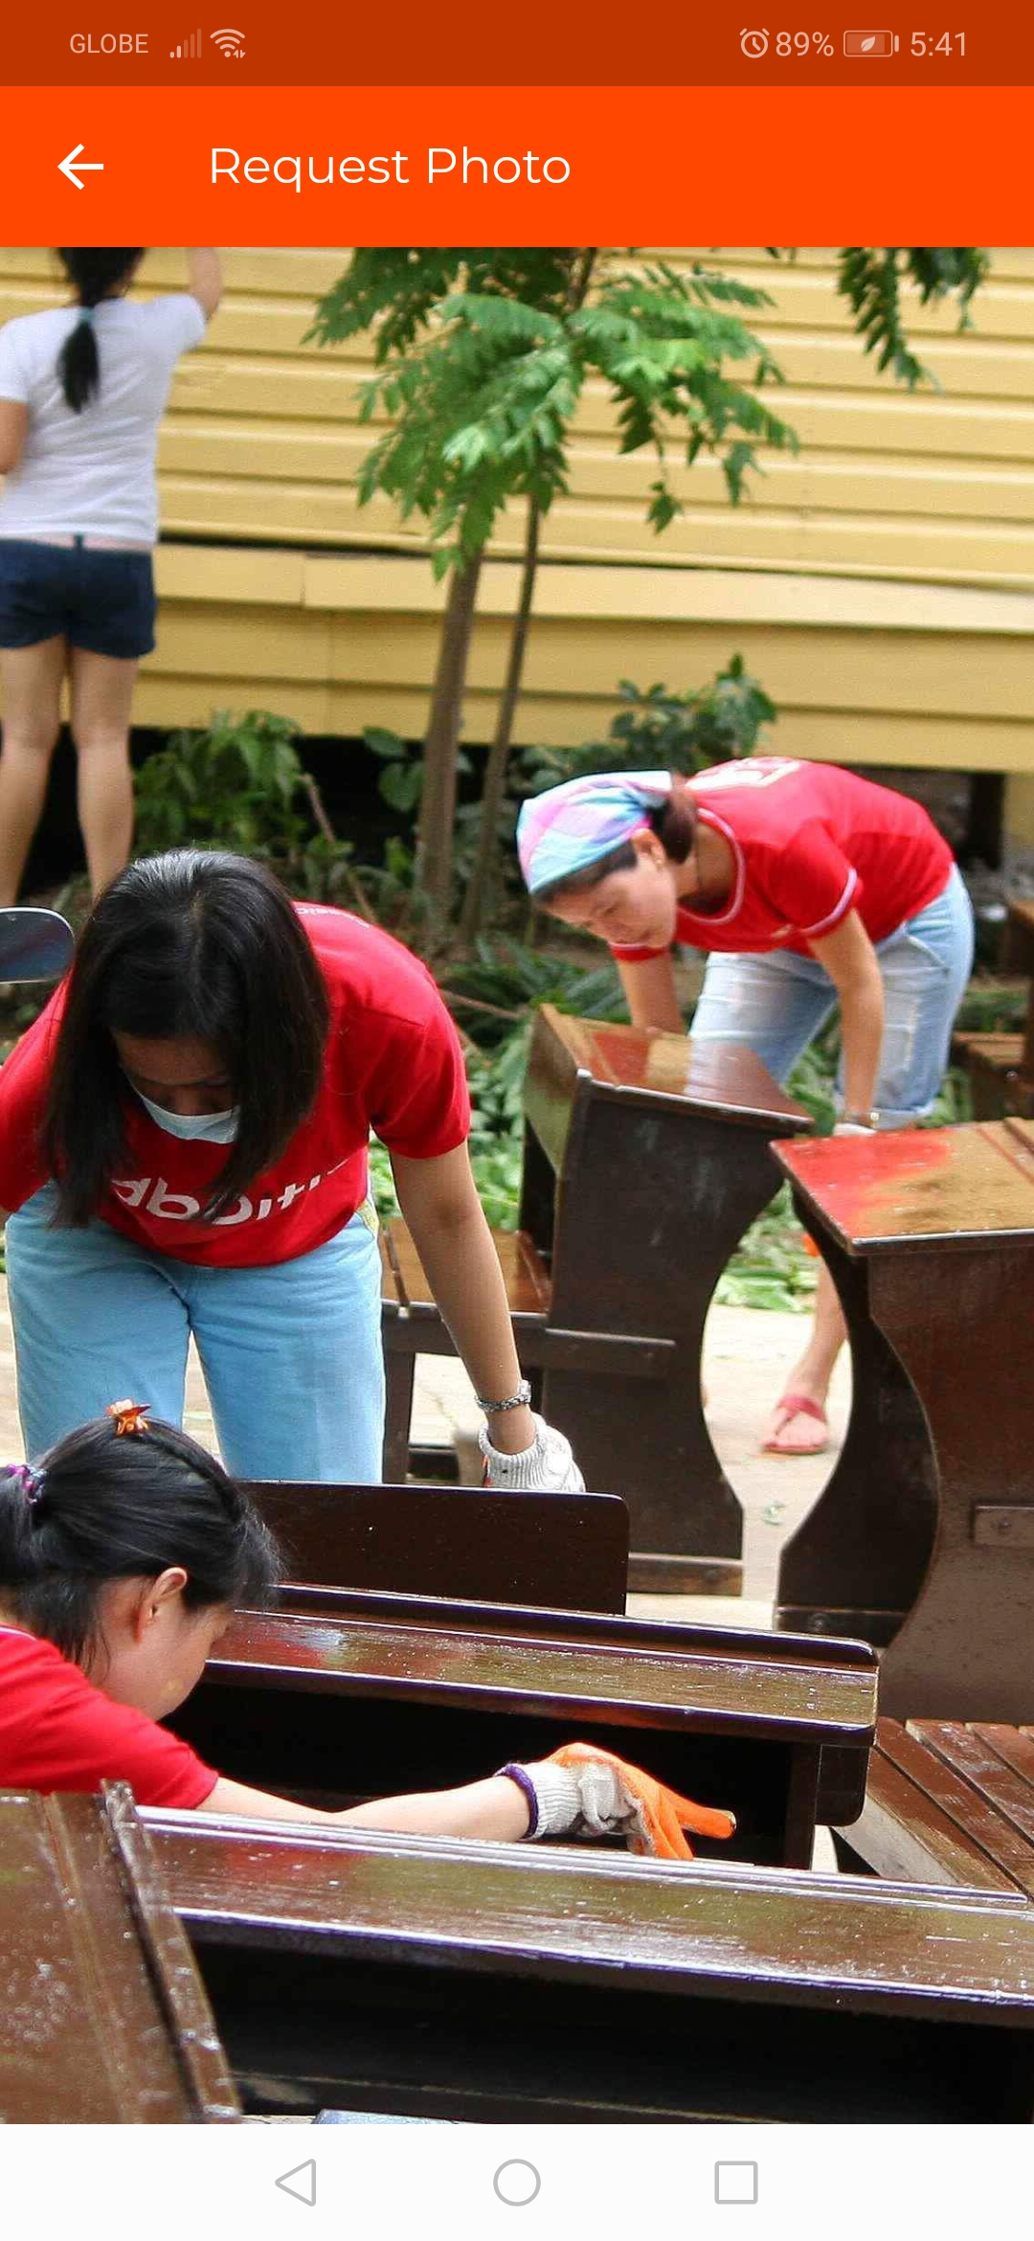

You can edit your request by just clicking the edit request button.

You can edit the **Request Title**, **Request Details** and **Date and Time** of your request.

We will try to change the Request Title, Date and Time of the request.

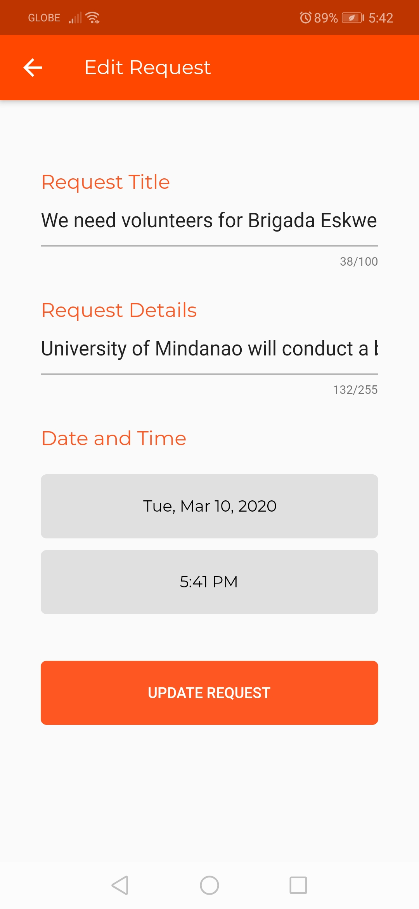

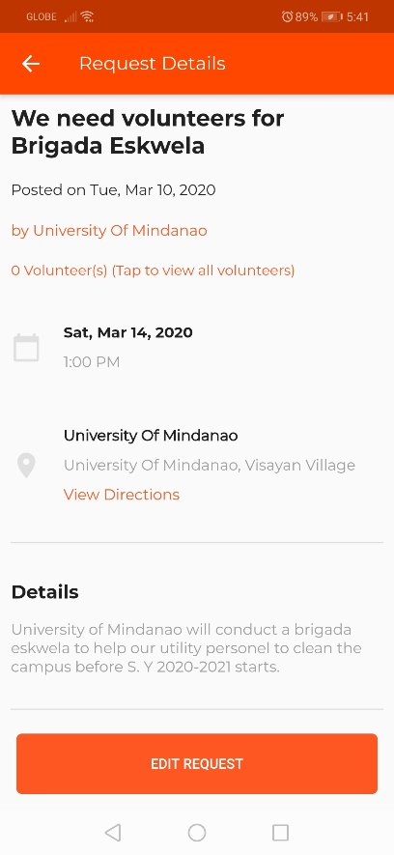

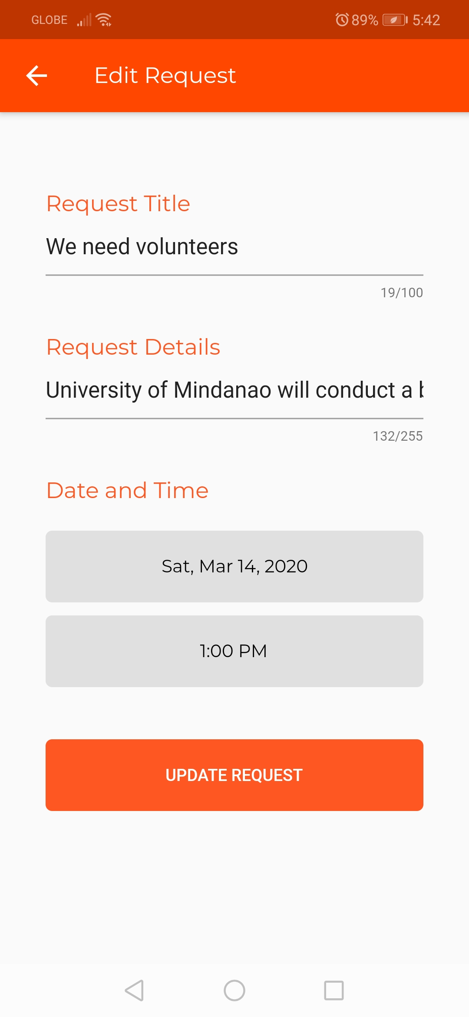

After changing the details tap the update request button to update.

***After the update the request title, date and time is updated***

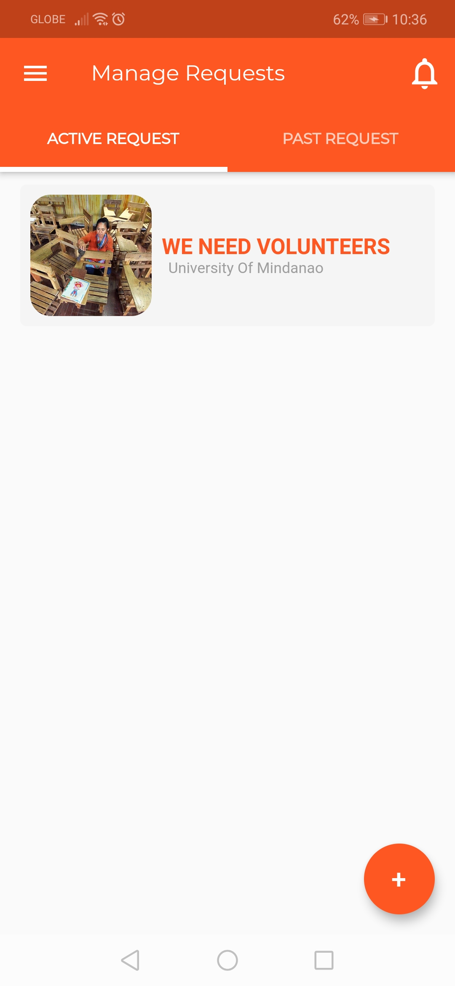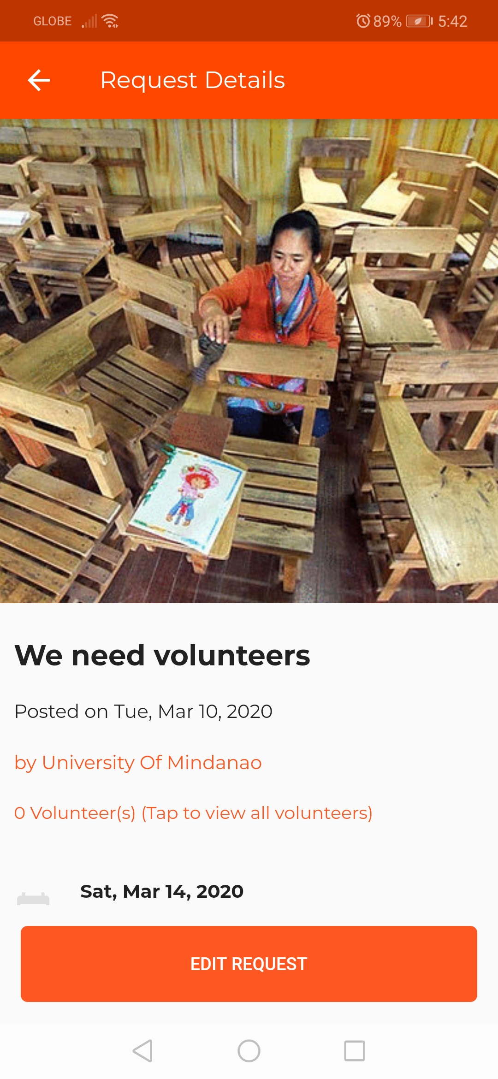

We are now done registering a school and adding a request we will now proceed to registration a volunteer and its functions.

1. **REGISTRATION FOR VOLUNTEER**

*REGISTER AS VOLUNTEER*

1. After tapping the VOLUNTEER BUTTON button on the sign up as page there are fields that you need to fill up.

First is the first name and last,

Second is your street address and city,

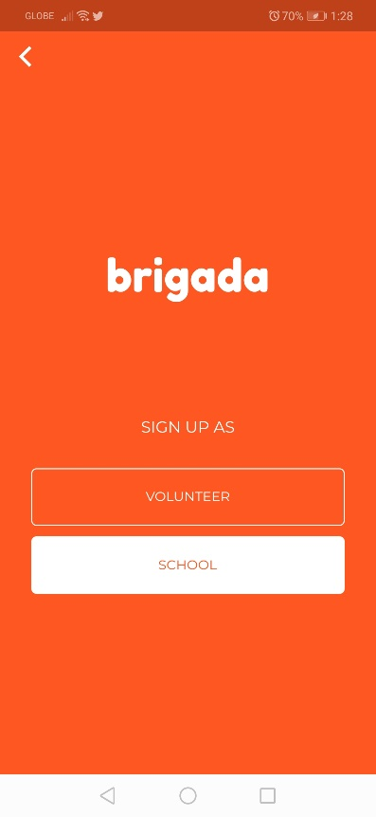

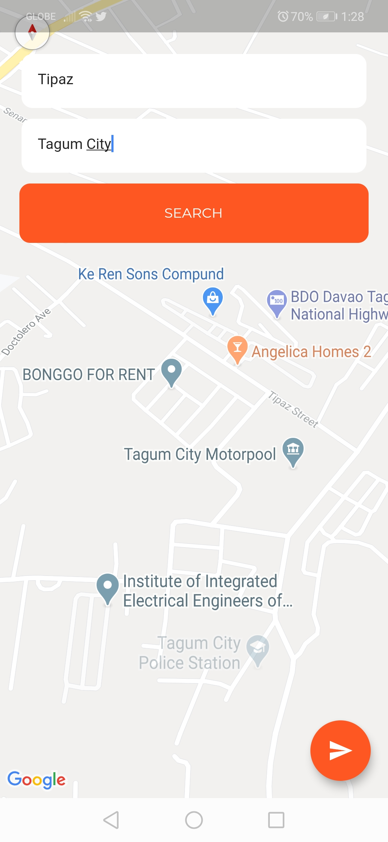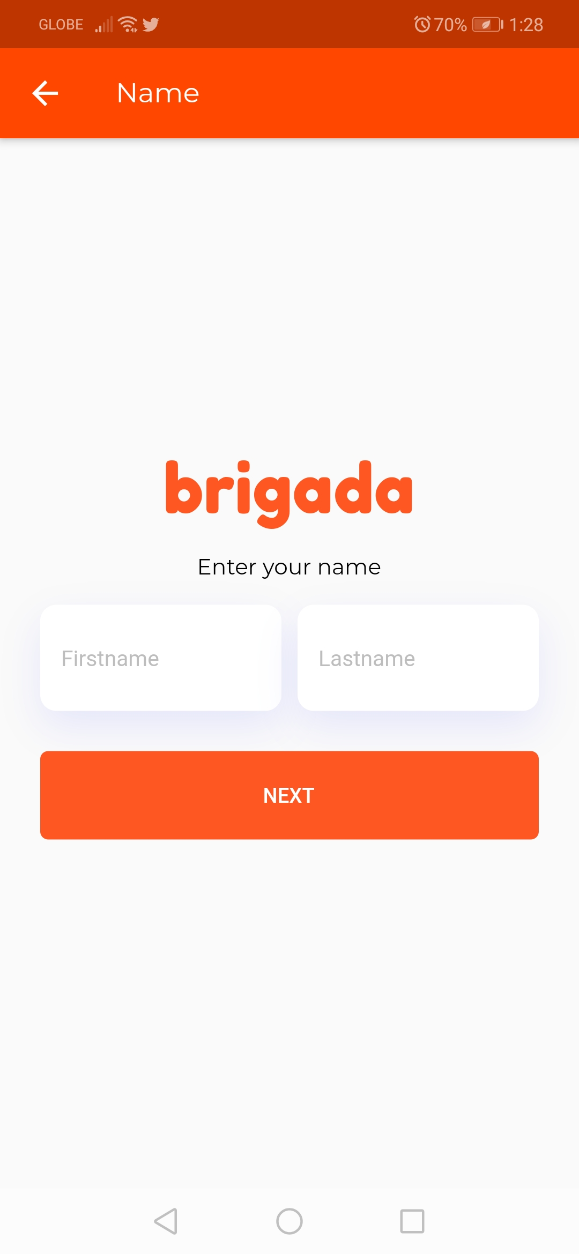

Caber

Charles Kurt

Third, your phone number tap **verify** and wait for the **text verification message**

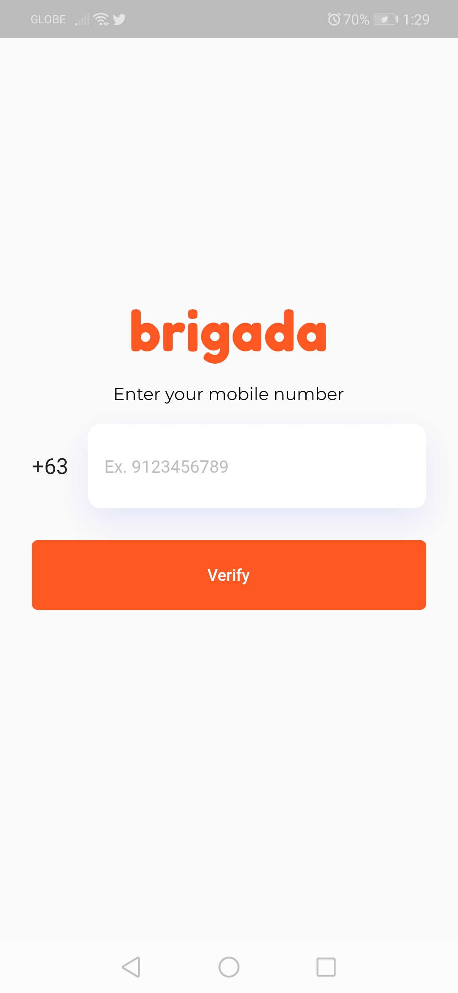

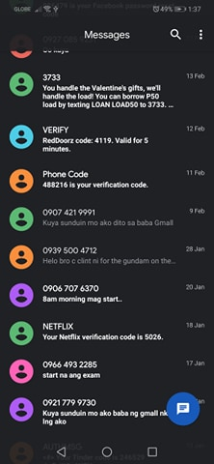

945695****

Tap Done and wait to be verified.

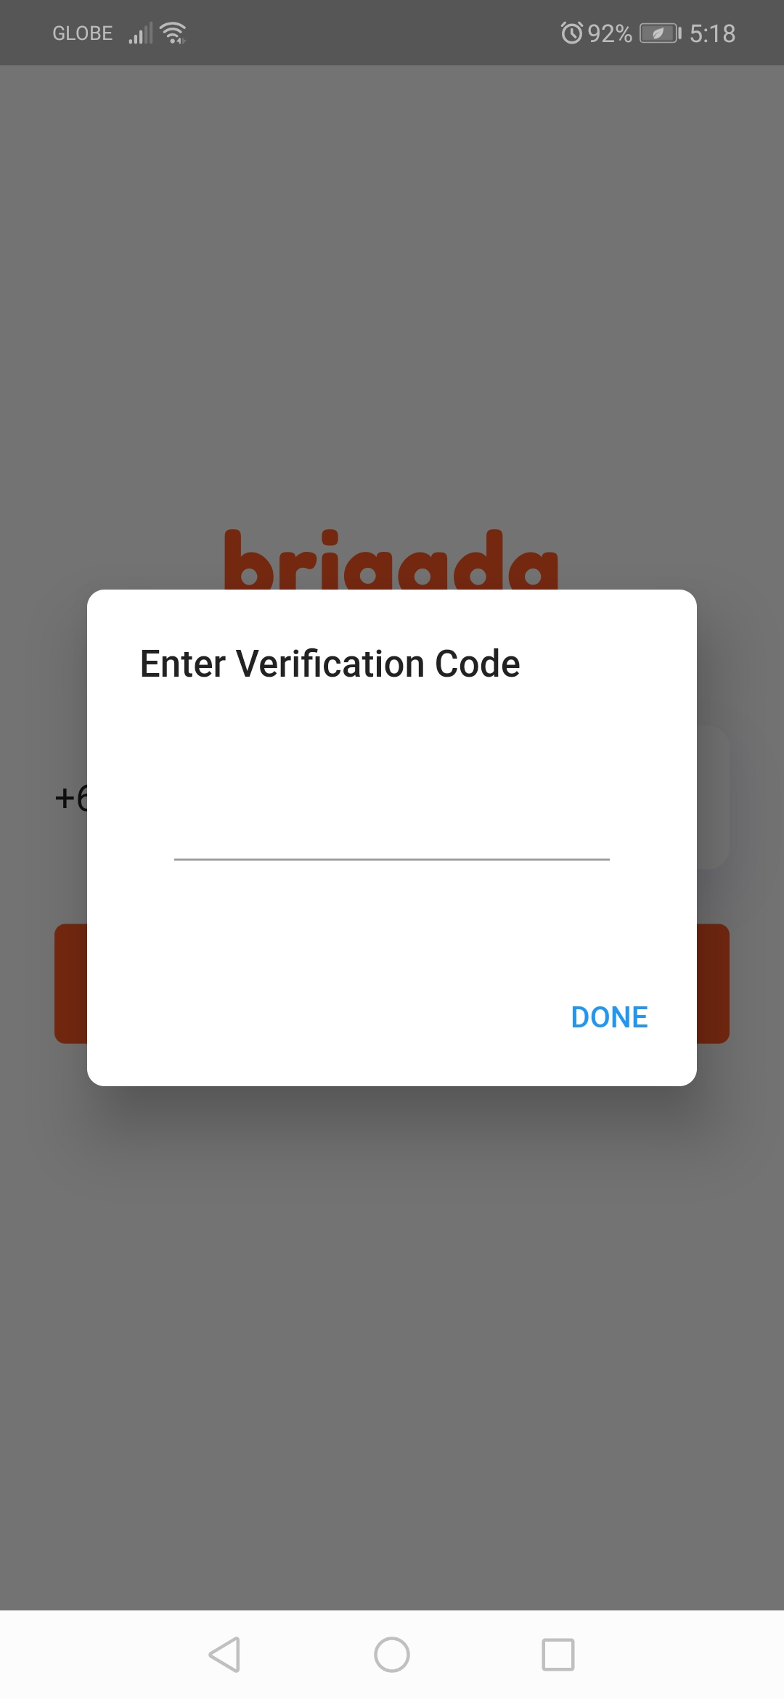

Tap Proceed

488216

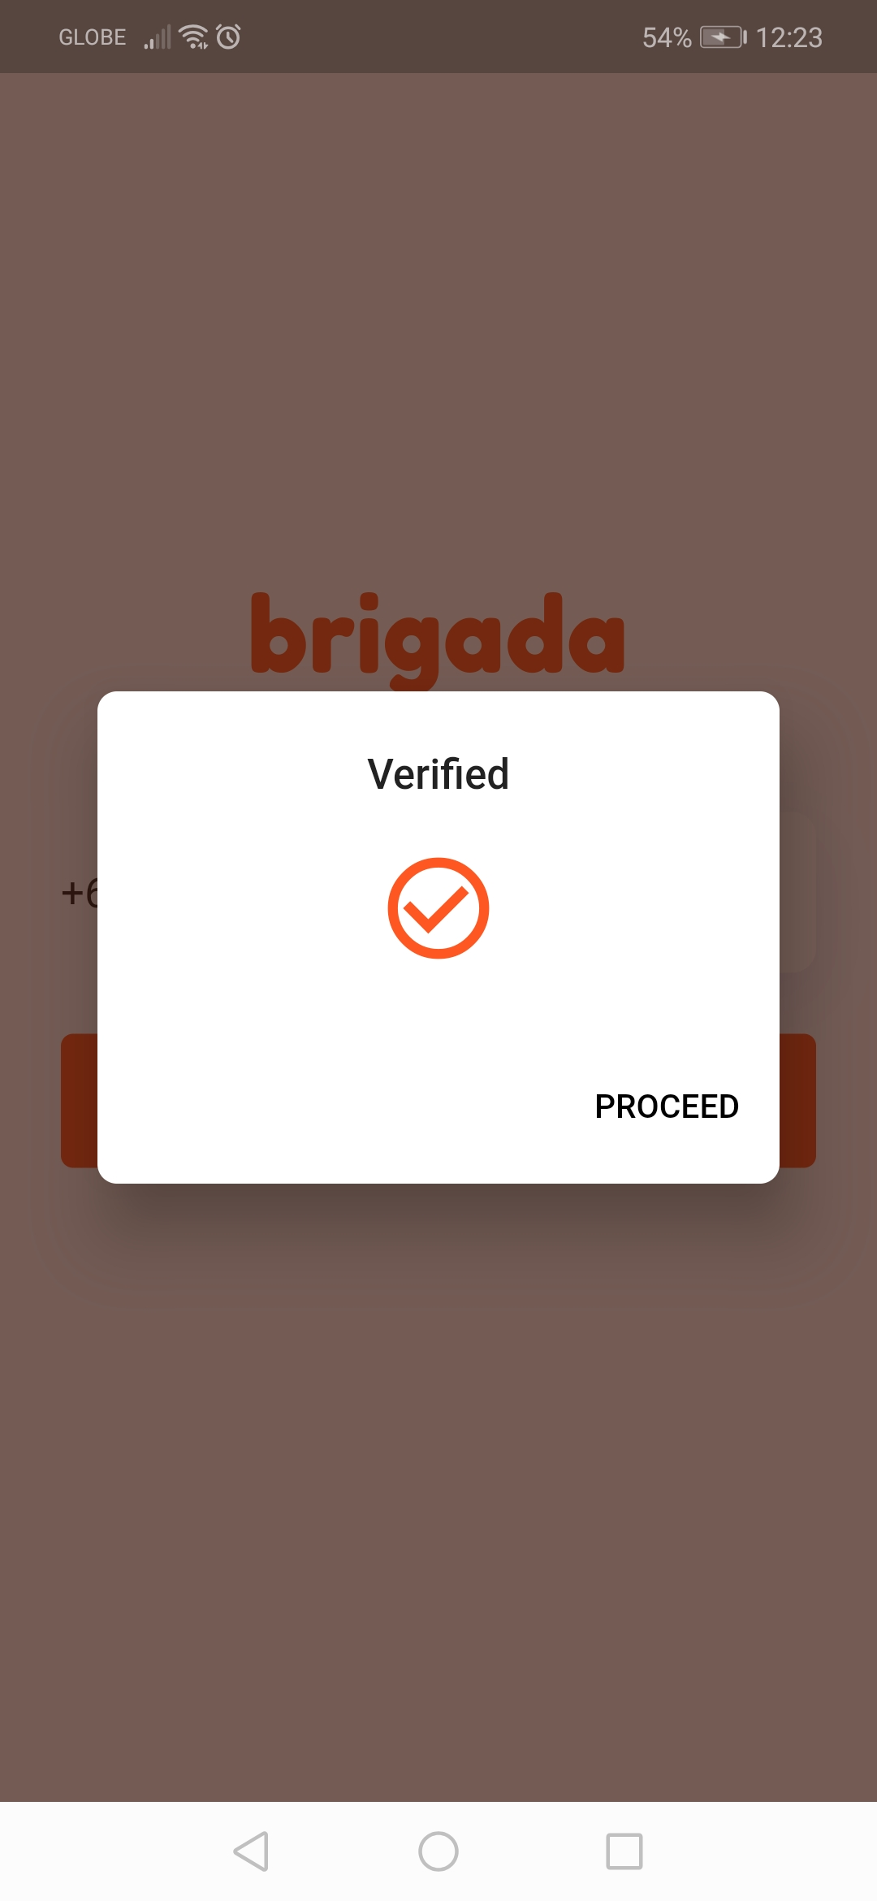

Fourth is the upload image screen

Last is the **Final registration** where you can register the email and password of your account.

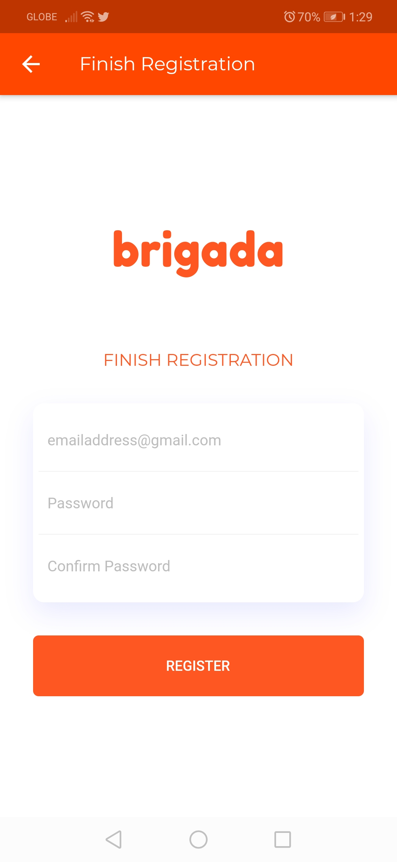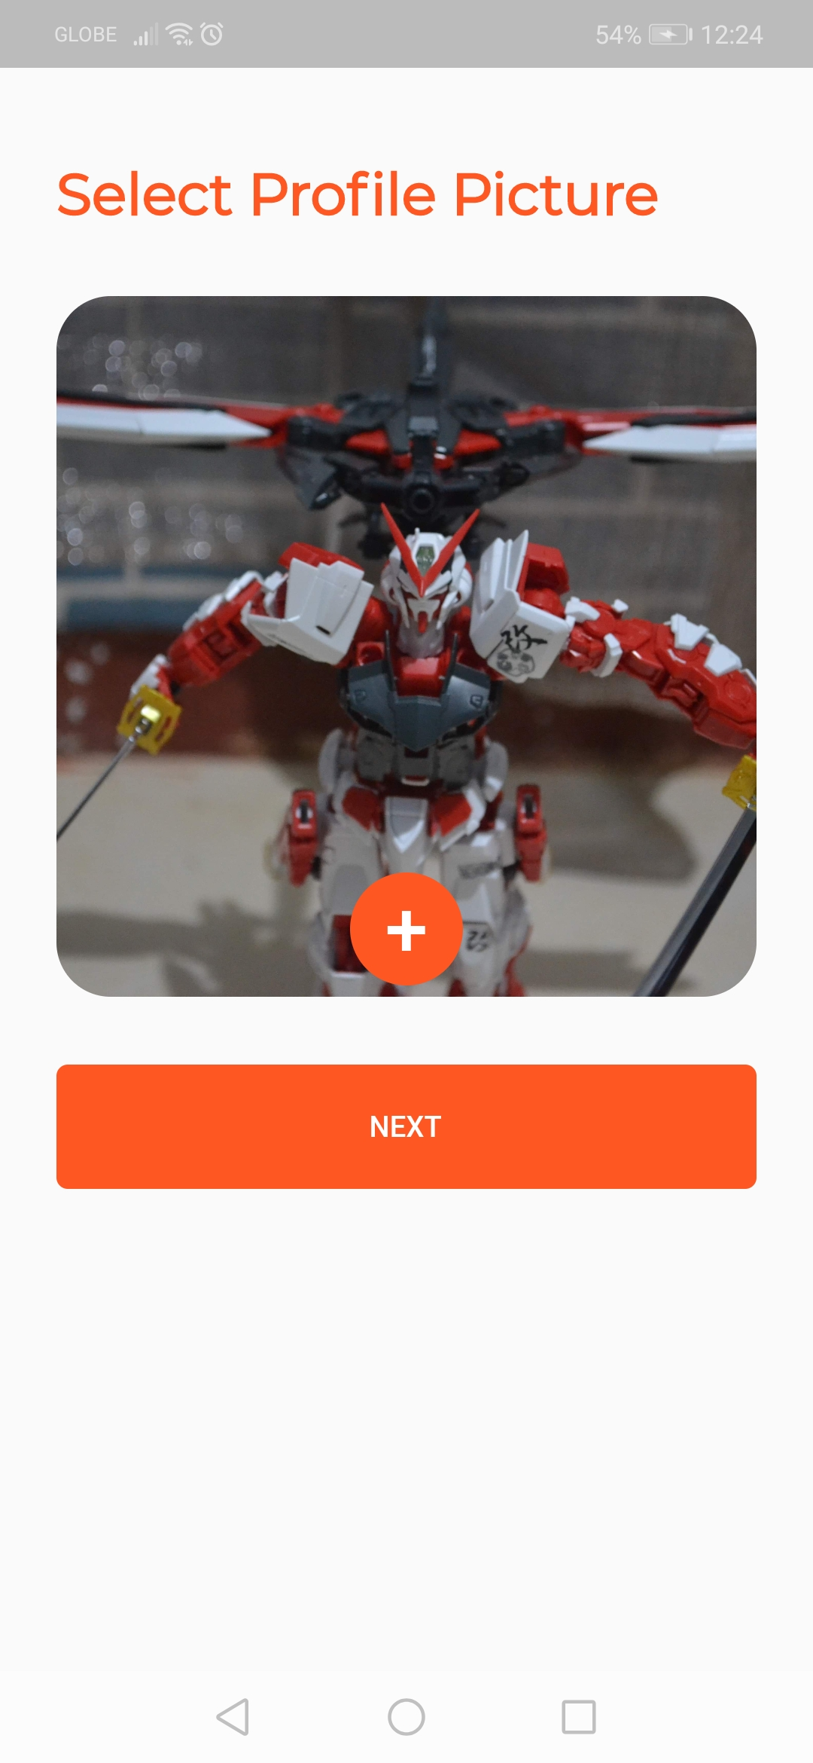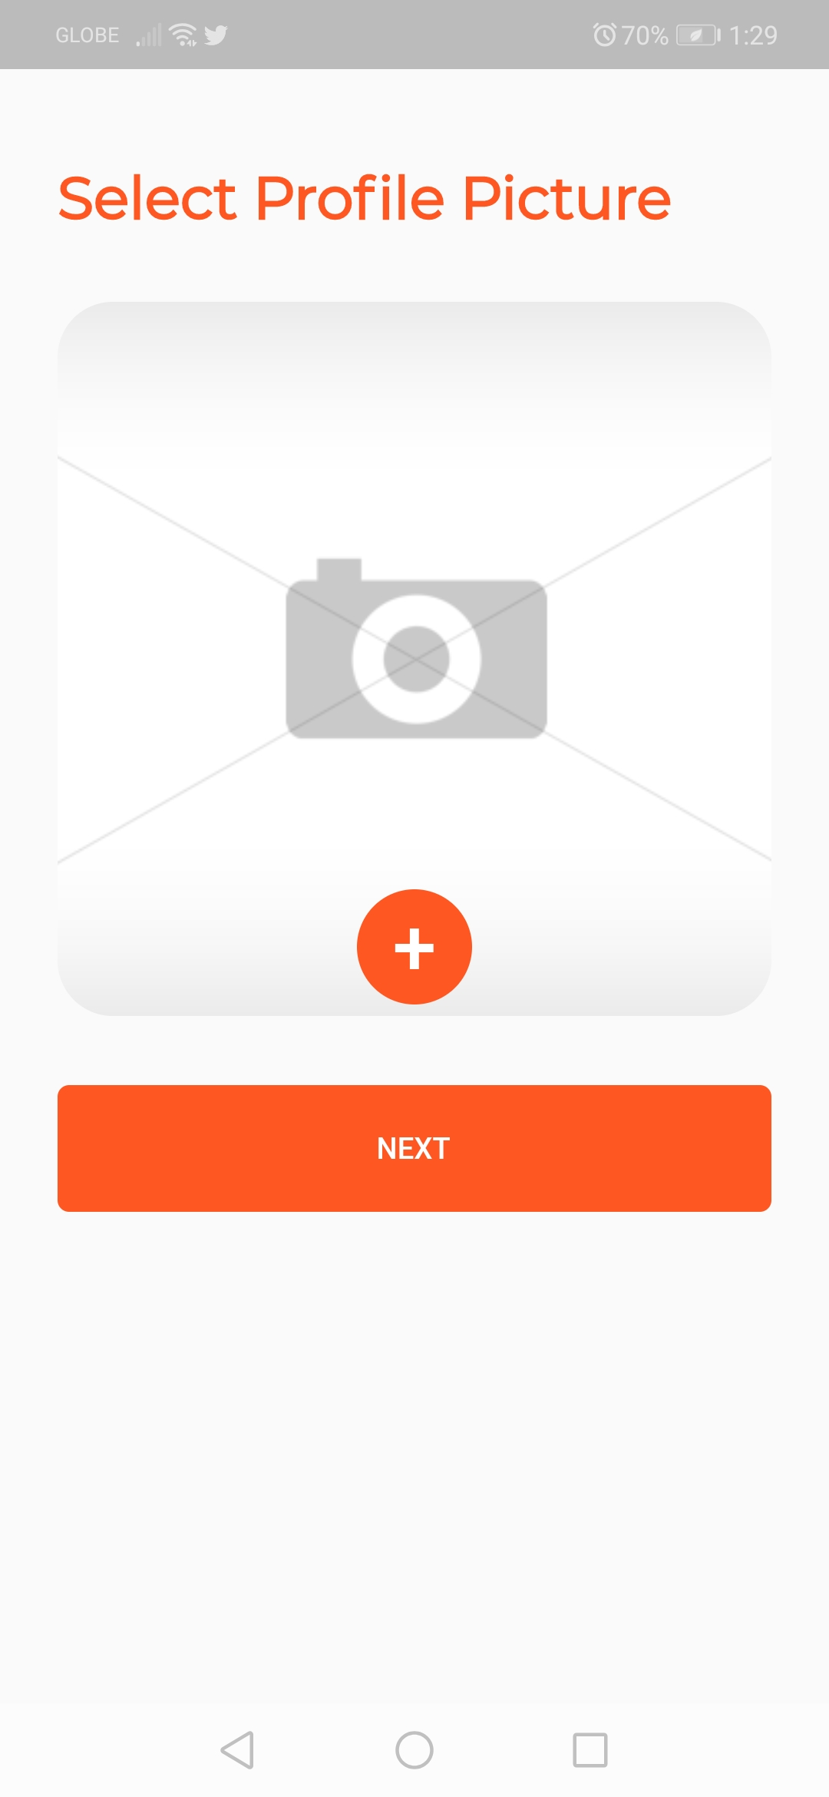

Tap the + button to select an image and click next

cabercharleskurt@gmail.com

******

******

***AFTER CREATING VOLUNTEER ACCOUNT***

LOGIN YOUR ACCOUNT

****Since we already added a request, and already logged in we can see the volunteer home screen where you can see the school requests.

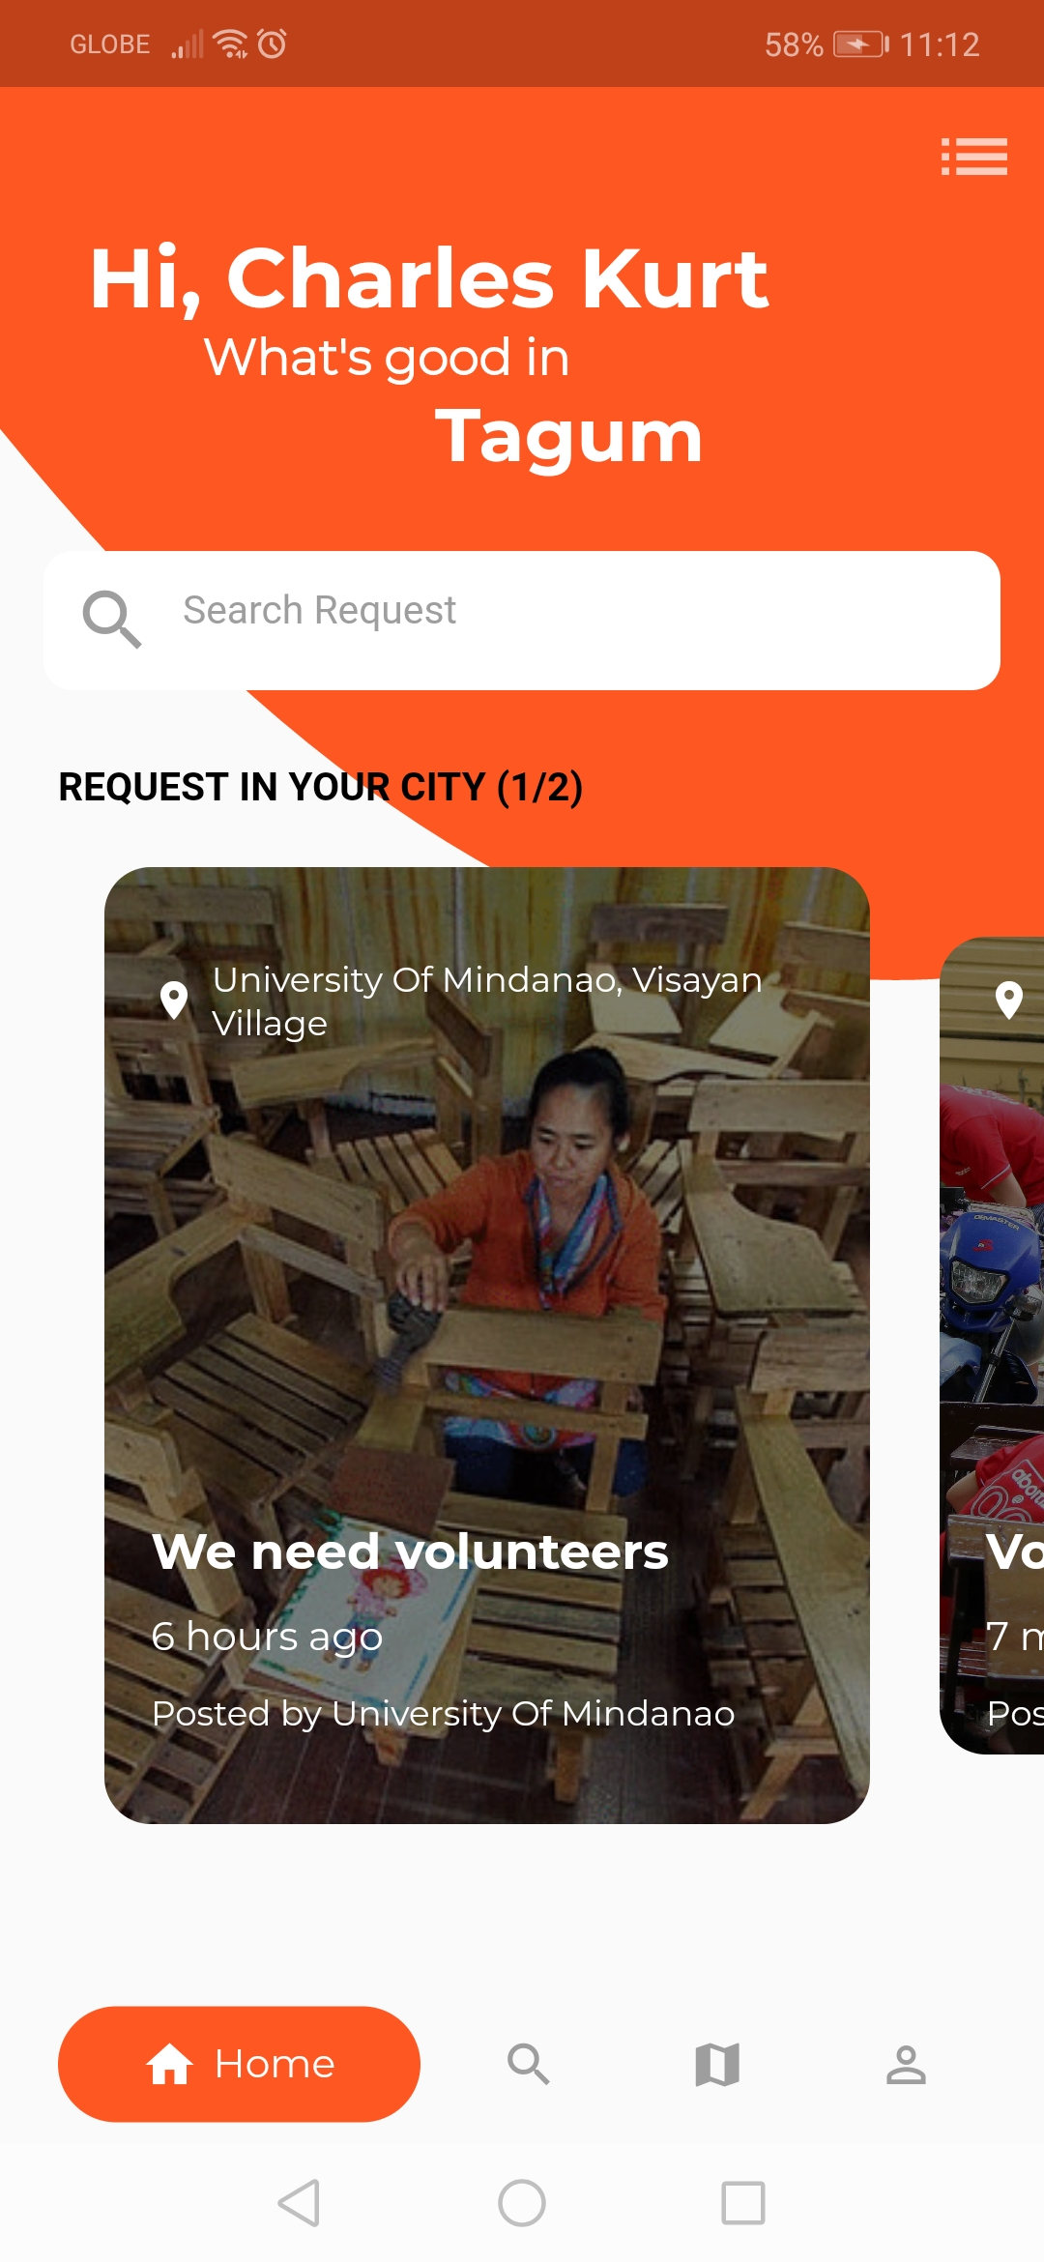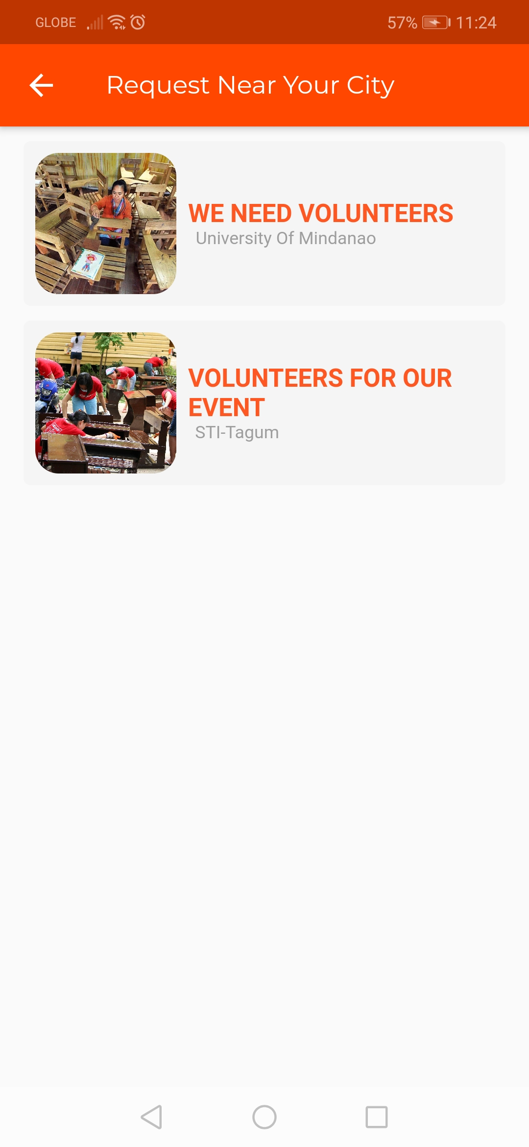

cabercharleskurt@gmail.com

******

You can switch to list view by tapping the list icon button.

1. **VOLUNTEERING TO A REQUEST**

*ACCEPTING A REQUEST*

Tap any of the request you want to request on the home screen on the list screen.

You can see the request details and the **volunteer button.**

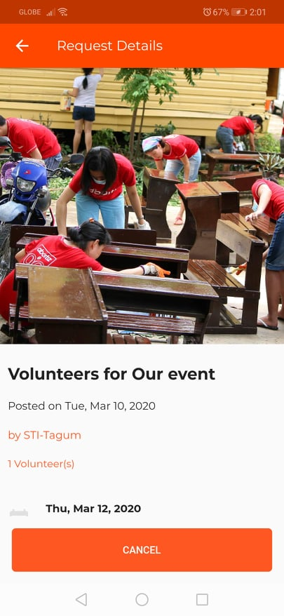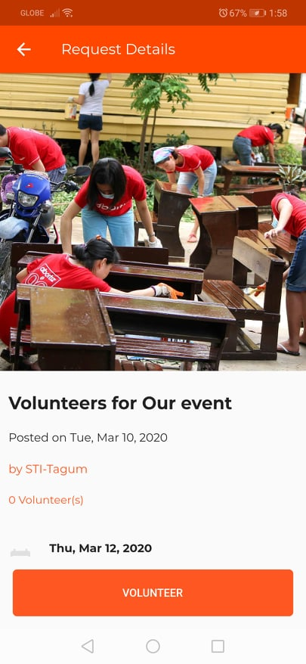

Tap to volunteer

Tap if you want to cancel



Tap to view school directions

Tap to view photo full screen

You can message the school by tapping the school name on the request detail page

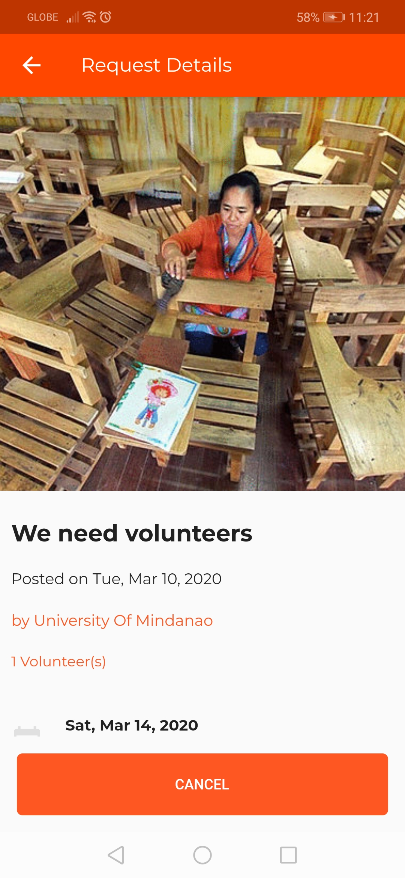

Tap the school name to view school details and message .

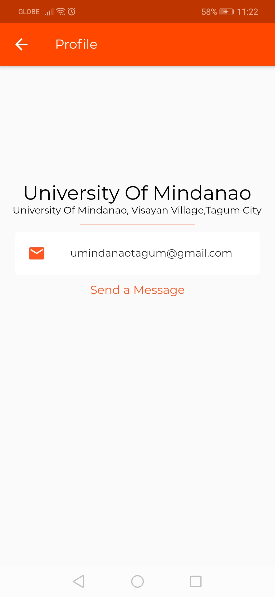

Tap to open the chat screen.

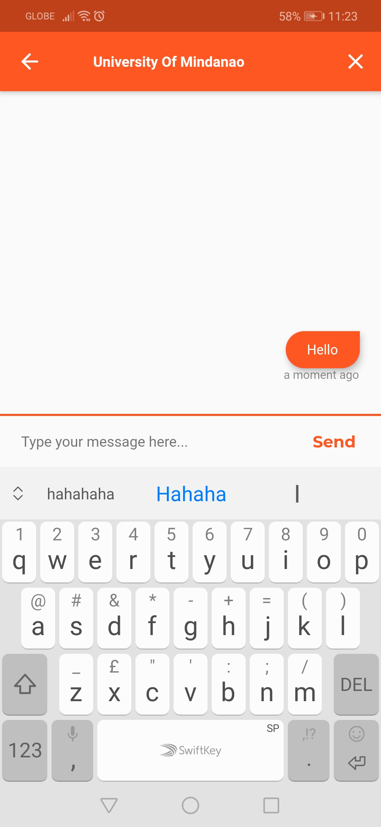

1. **OTHER BUTTON NAVIGATION**

*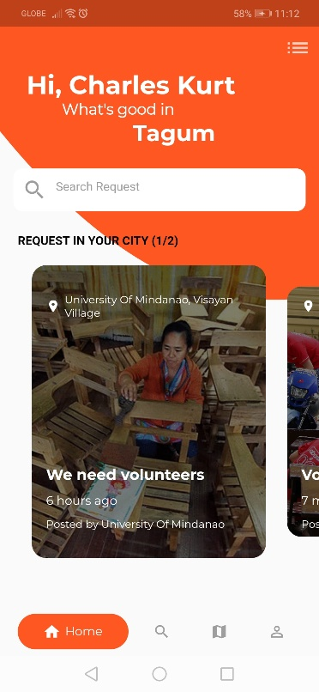Let’s explore now the other navigation buttons.*

1. ***Search Navigation***

In this area if the user doesn’t search anything it will display all the request near you.

If you want to search type the school name and you will all request created by the school you search.

If you tap any of the request it will redirected you to the request details page.

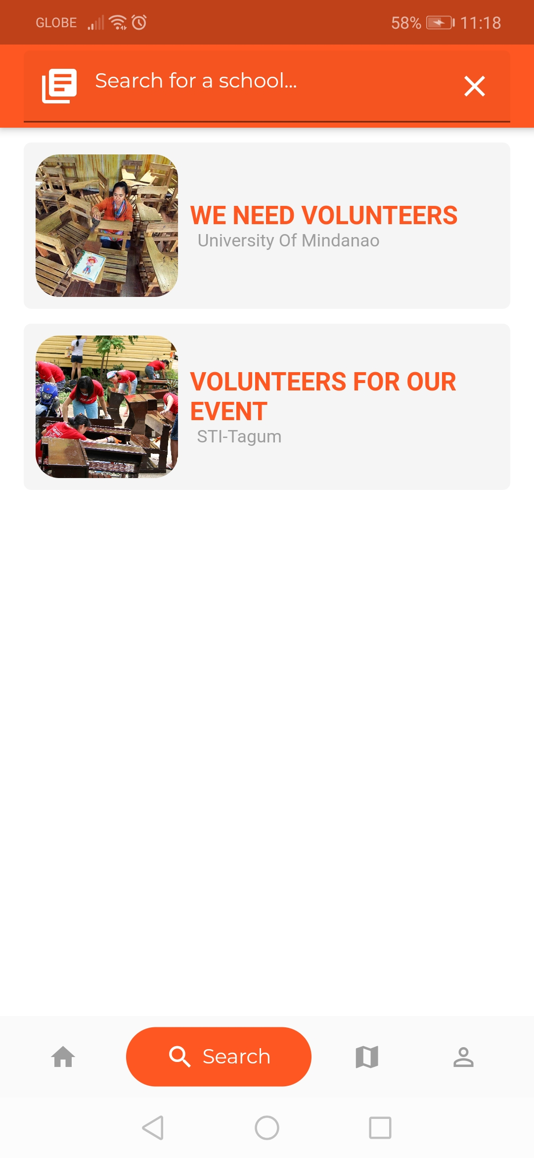

1. ***Map View Navigation***

This area will show you all the request in rows.

When you tap any of the request the map will go the direction of the request.

You can see all the request based on the red marker in the map.

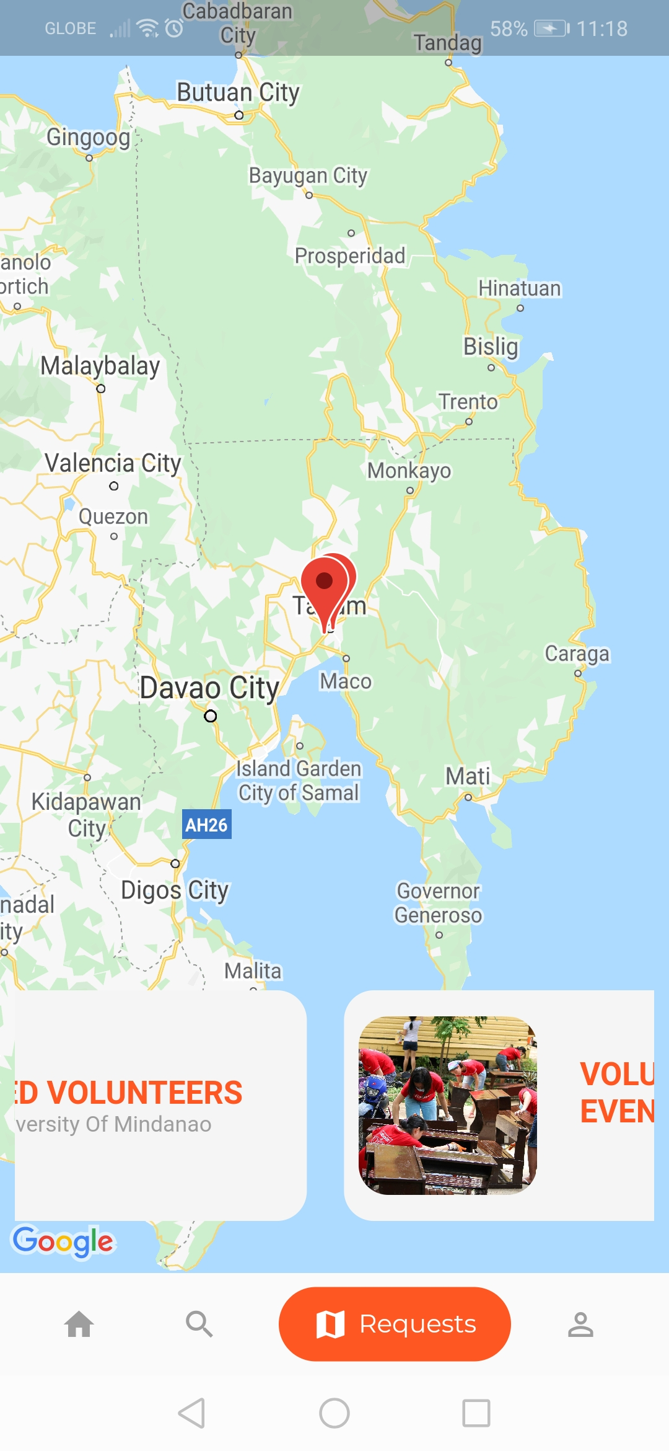

1. ***Profile Navigation***

**View Messages**

**View Profile**

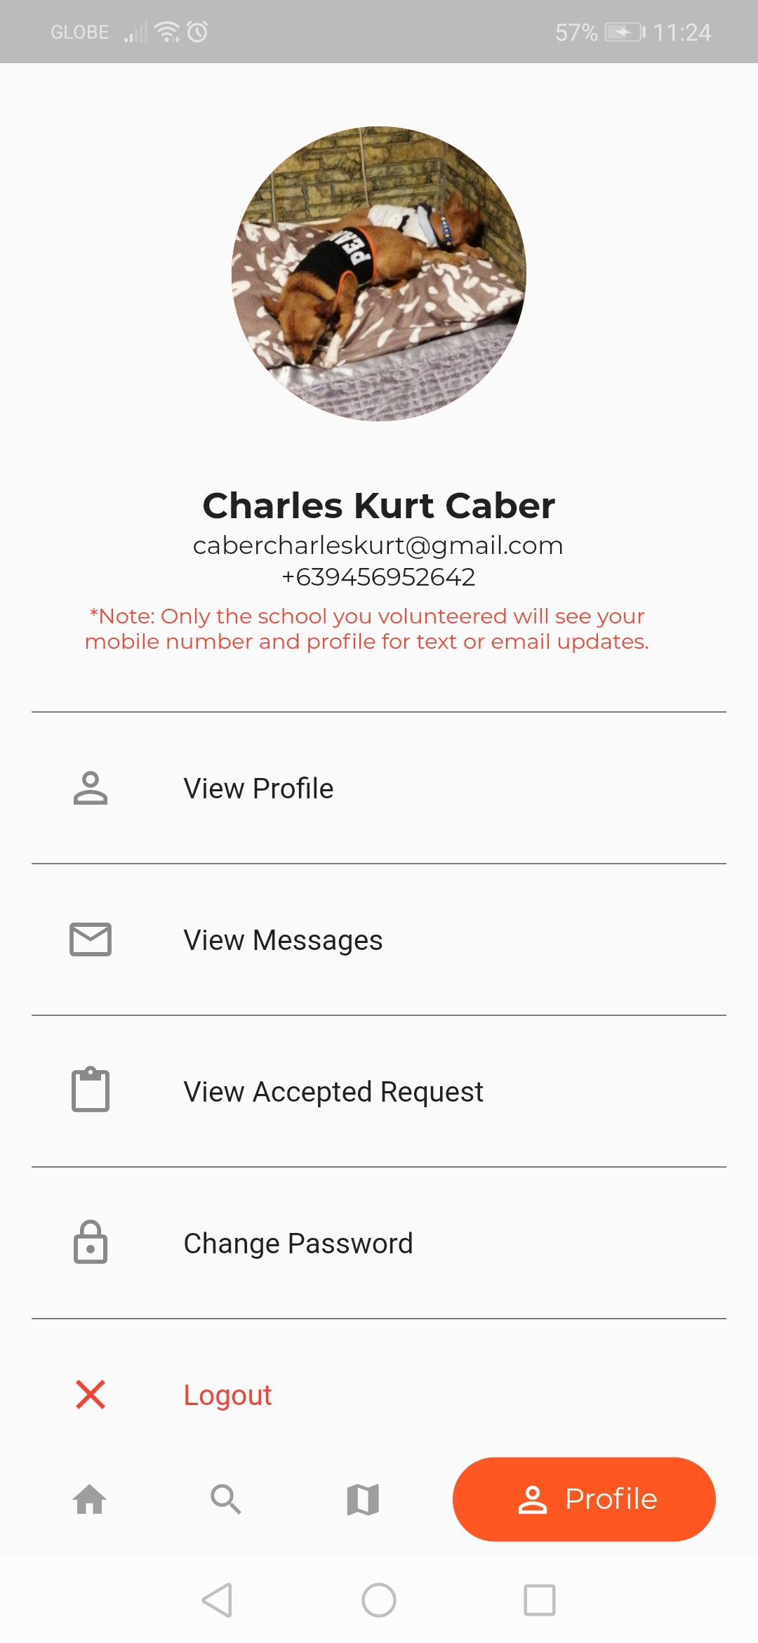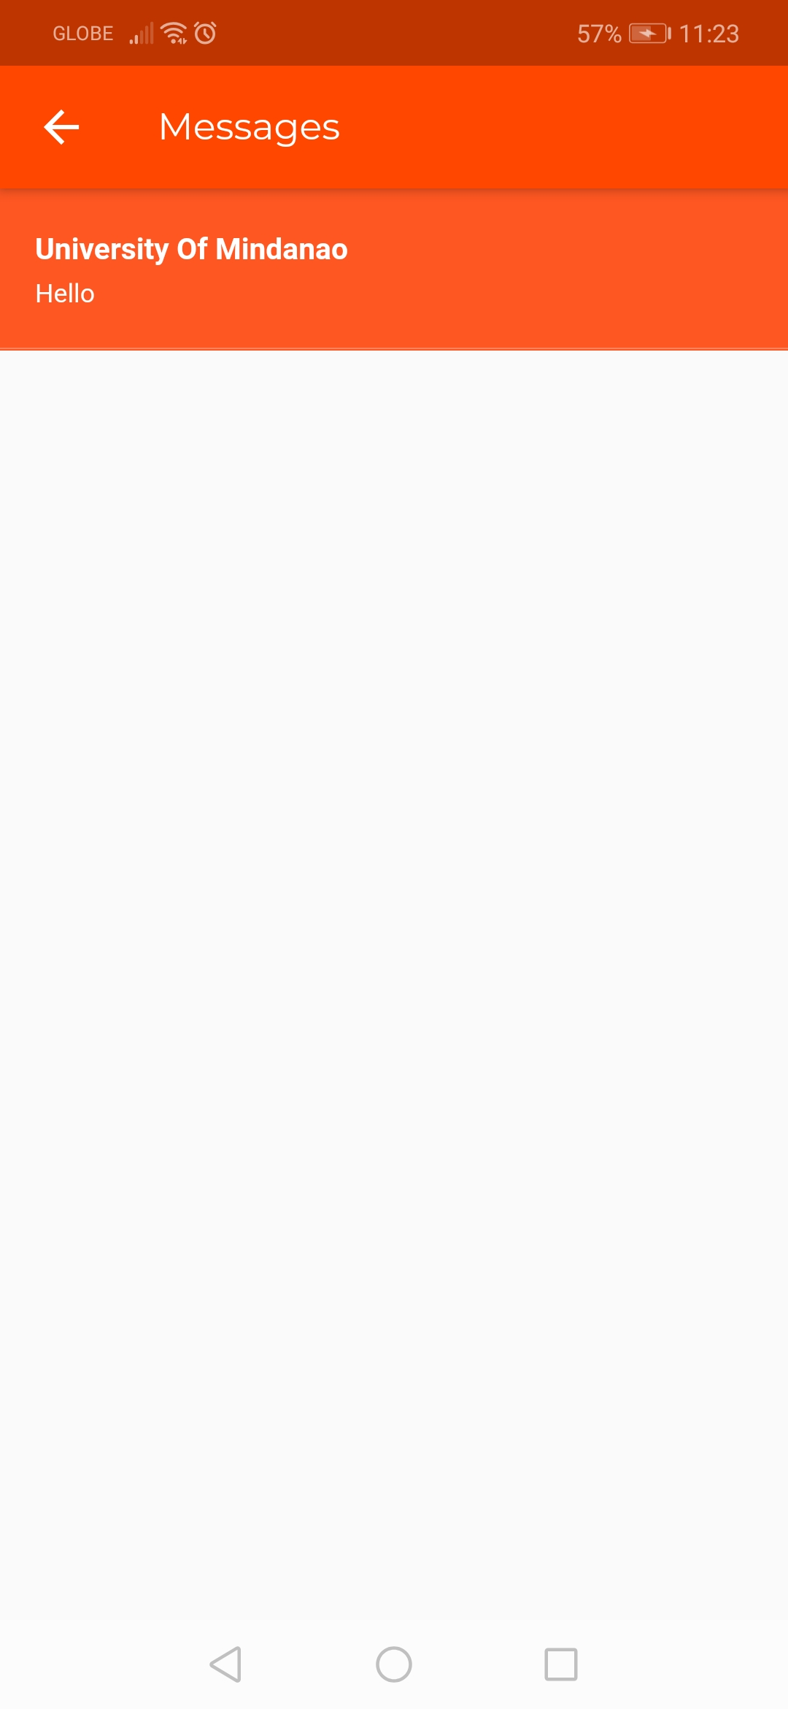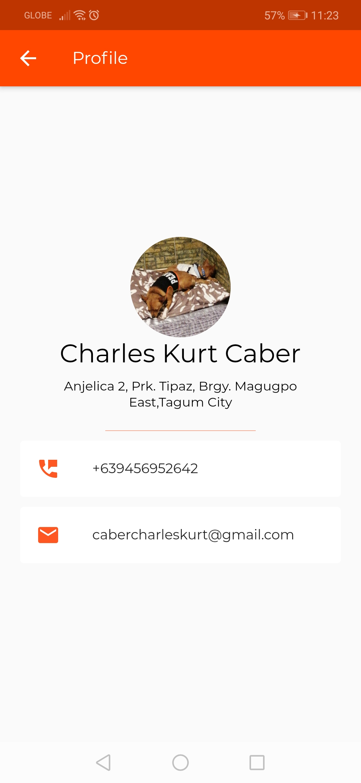

All messages will be displayed here

**Change Password**

**View Accepted Request**

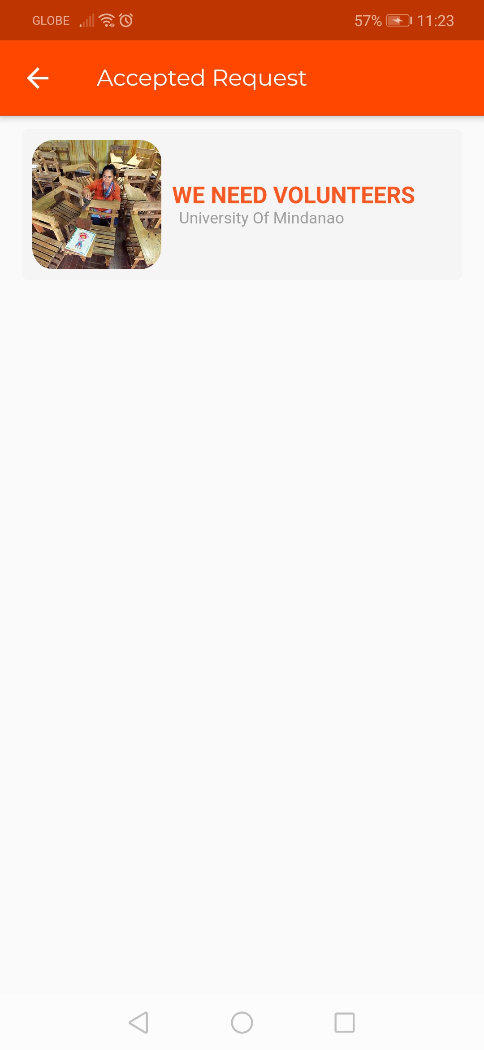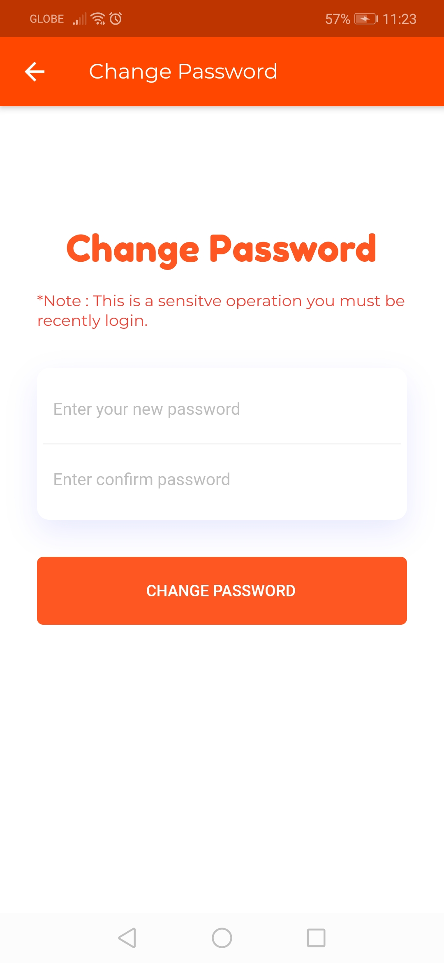

All accepted request will be displayed here

We are done exploring all of the functions and menus of the Volunteer account. Next we will go back again to the school account to see what happens when the volunteer accepted the request and message you.

1. **OTHER SCHOOL ACCOUNT FUNCTIONS**

Bell Icon (Notifications)

Hamburger Icon

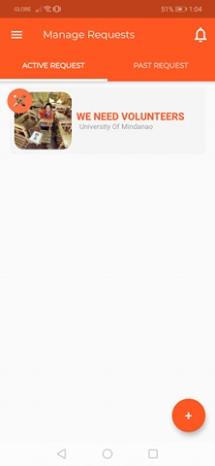

**Hamburger Icon**

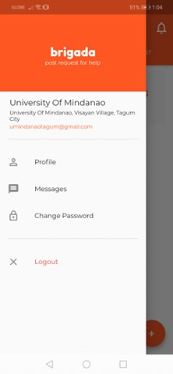

Past Request Button

**Bell Icon (Notifications)**

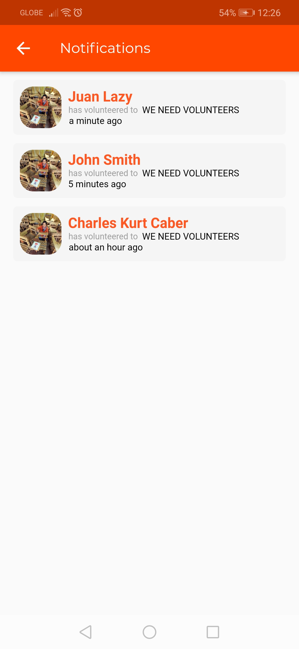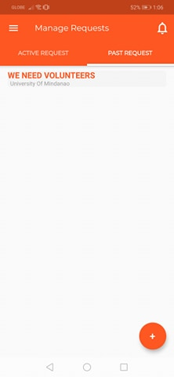

**Past Request Button** – is for transferring your request to past request tab. If the request is already done.

You can also delete the past request.

On the Active Request you can tap any of the request to check all the volunteers





To see all the volunteer tap the volunteer(s) text

To message thru text all the volunteers for update you can click the messaging icon here.

**Sample list of volunteers**

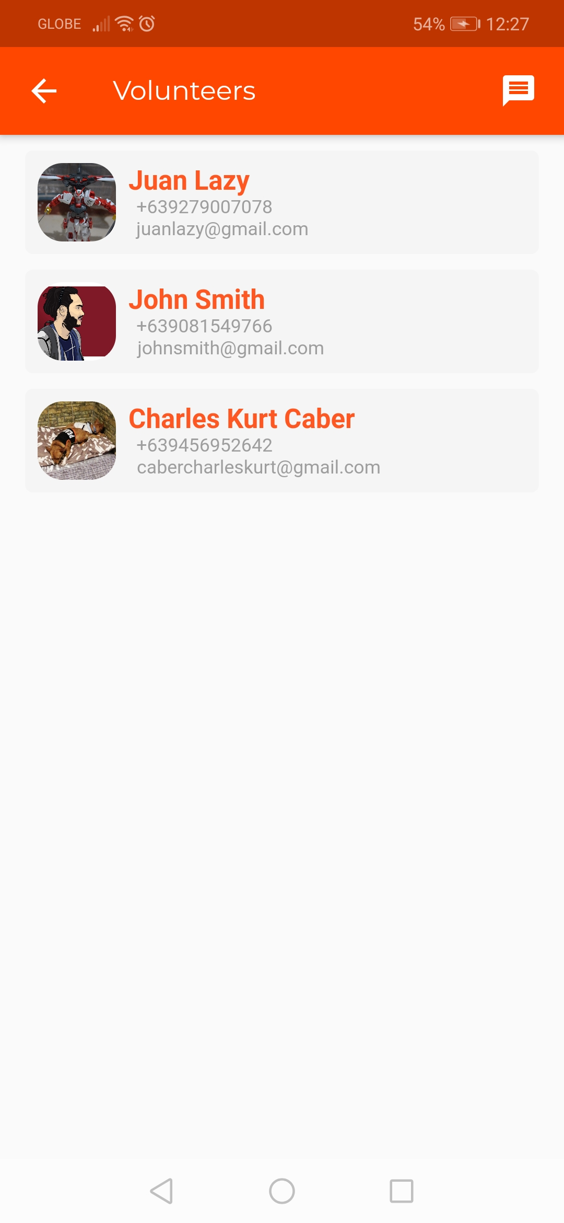

**SCHOOL CHAT FUNCTION**

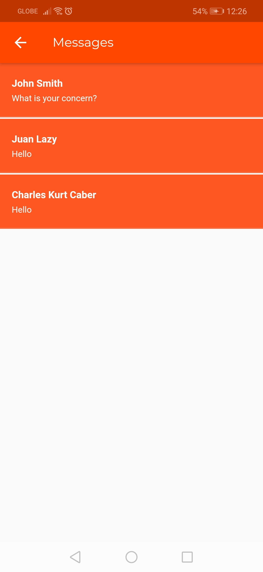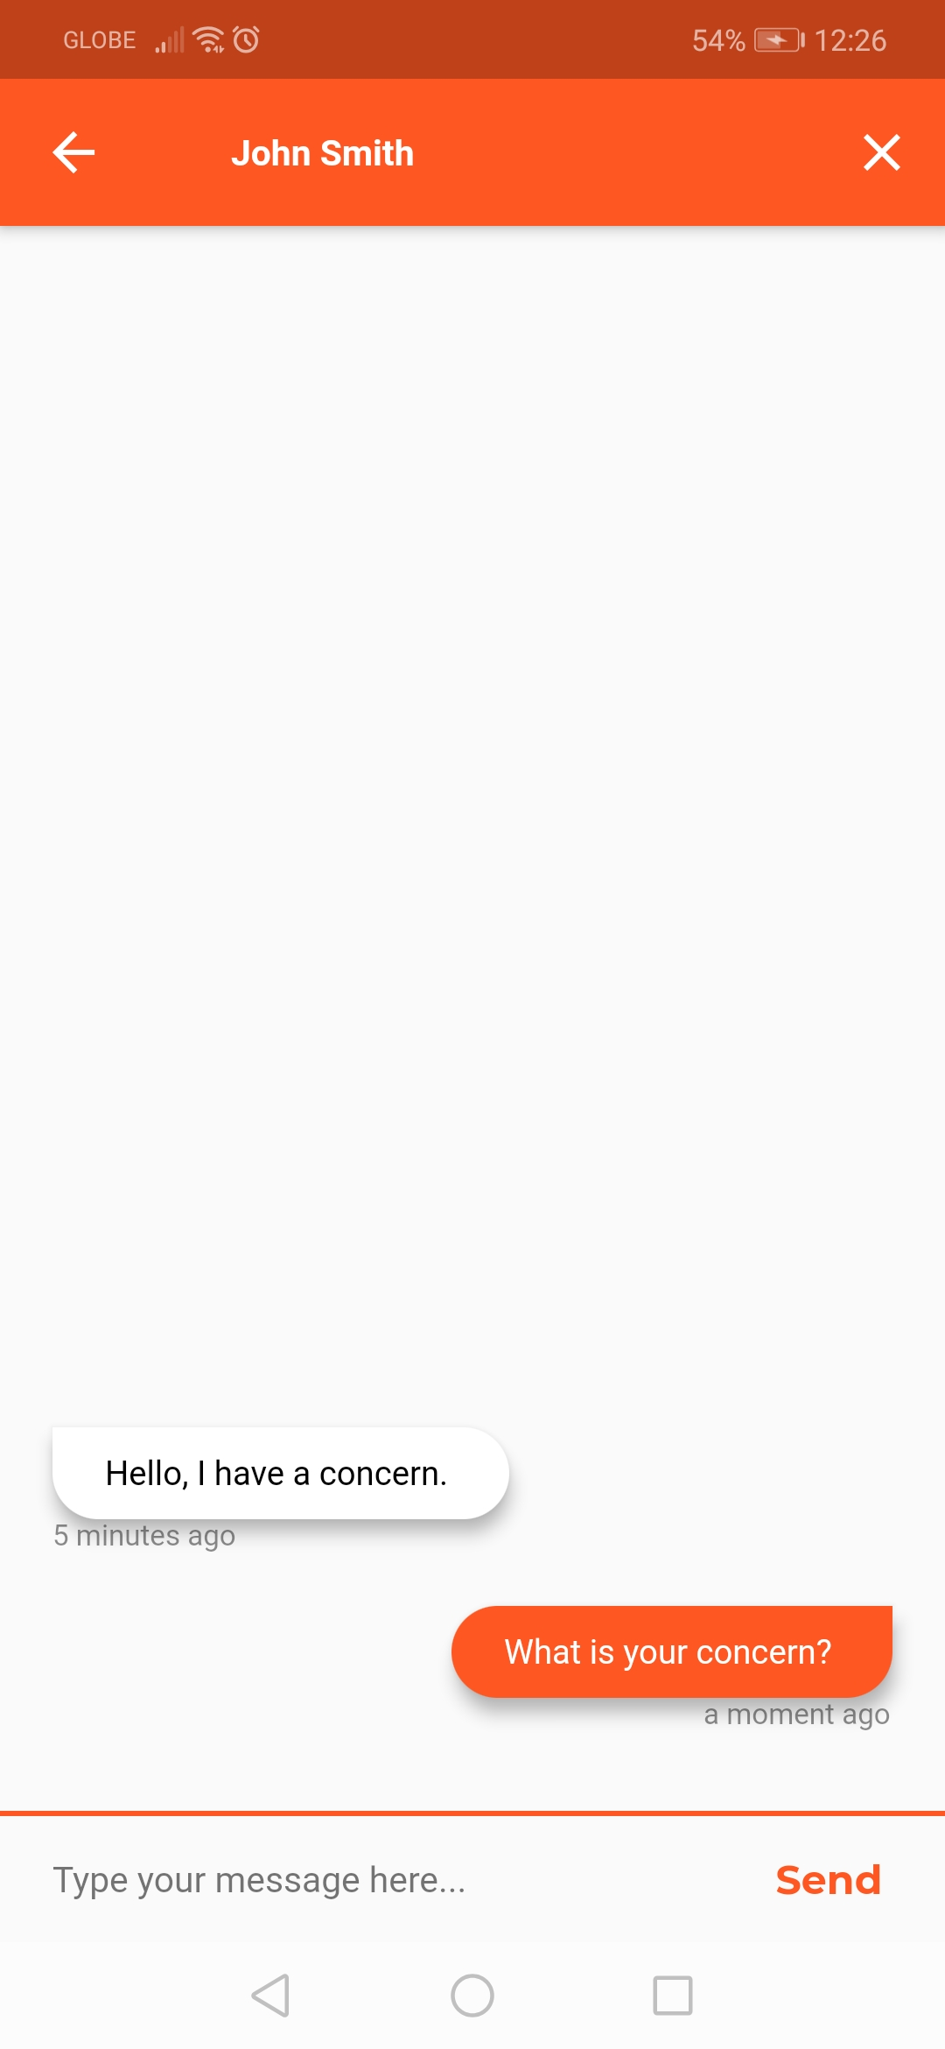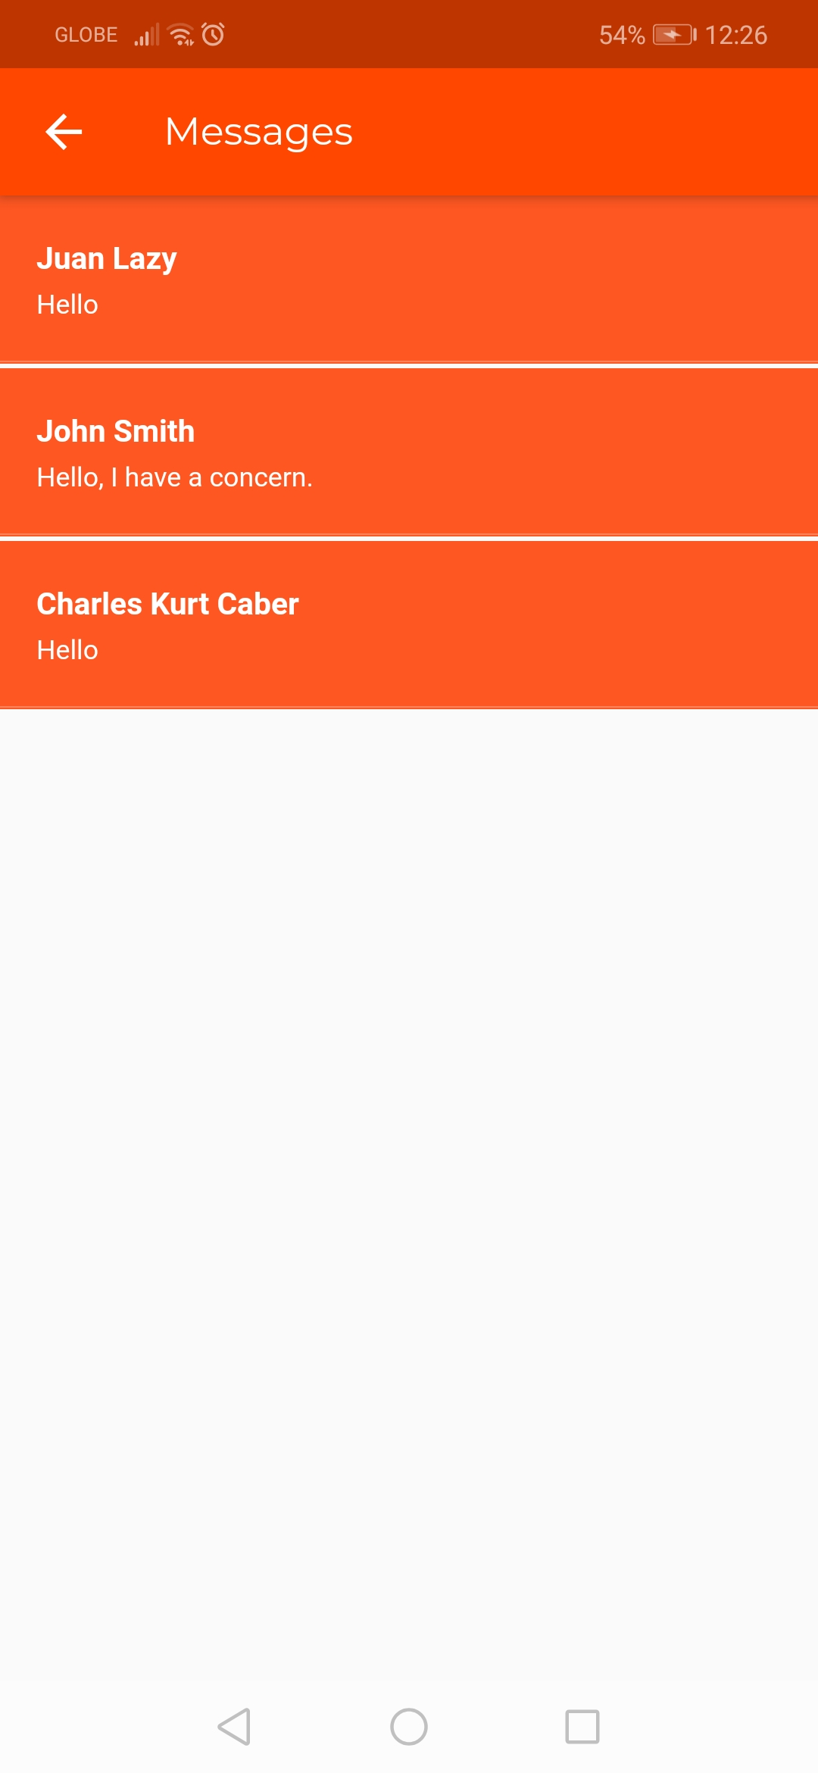

**EXTRA FUNCTION**

***Report Account***

At the bottom of the request details as a volunteer you can see the report request. Just tap the text and you email the admin for your report.

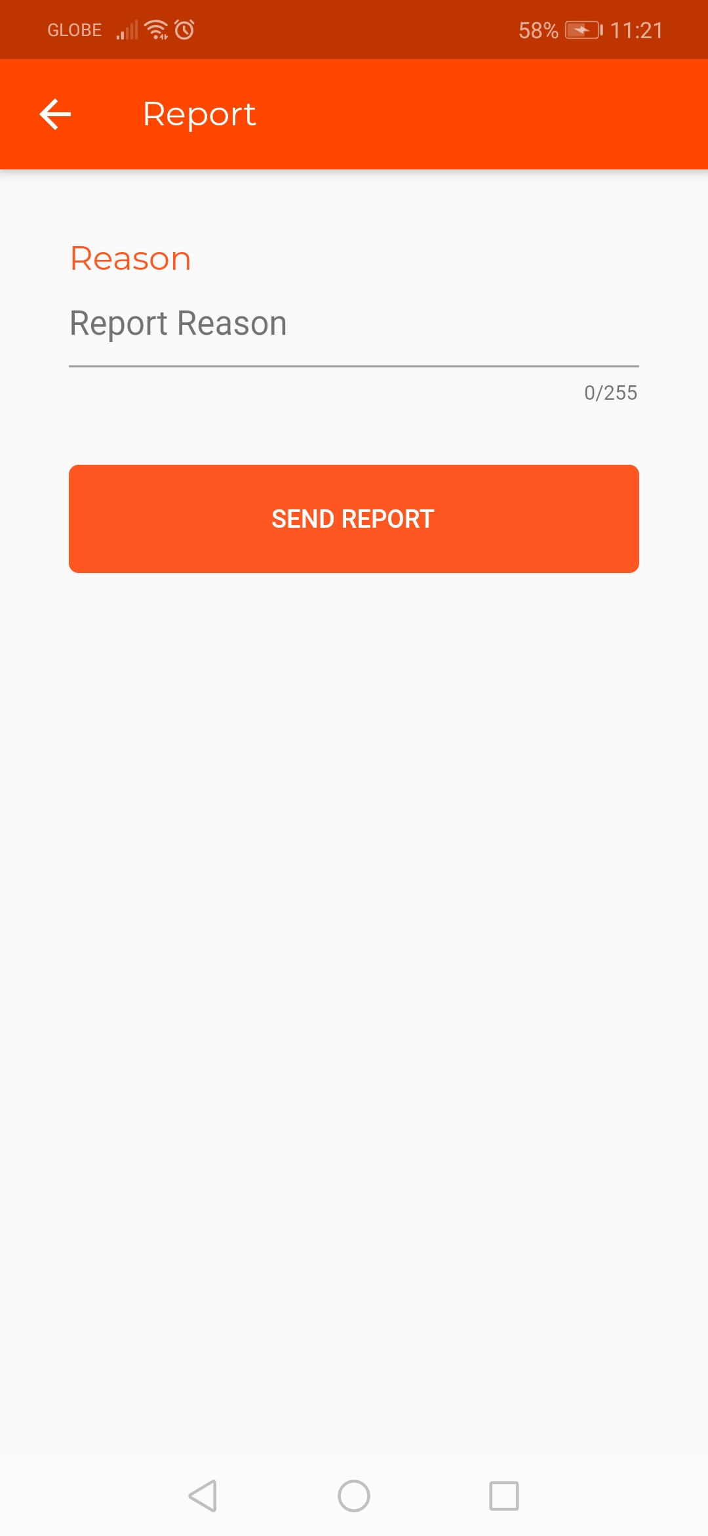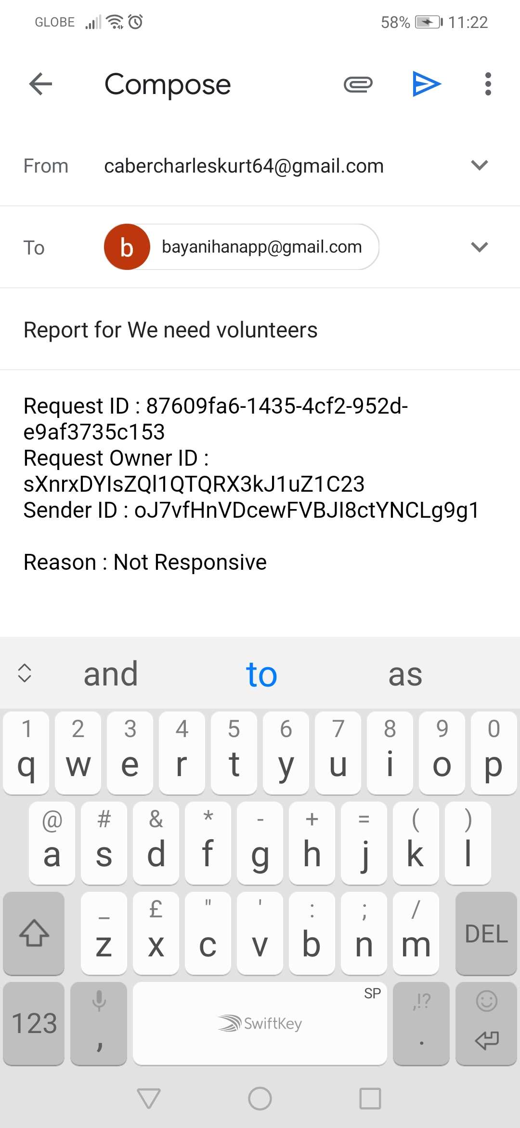

***FORGOT PASSWORD***

On the login screen you can see the forgot password text. Just tap it if you forgot your password.

Enter your email address that your are using on the app and automatically you will receive a reset password confirmation in your email address.

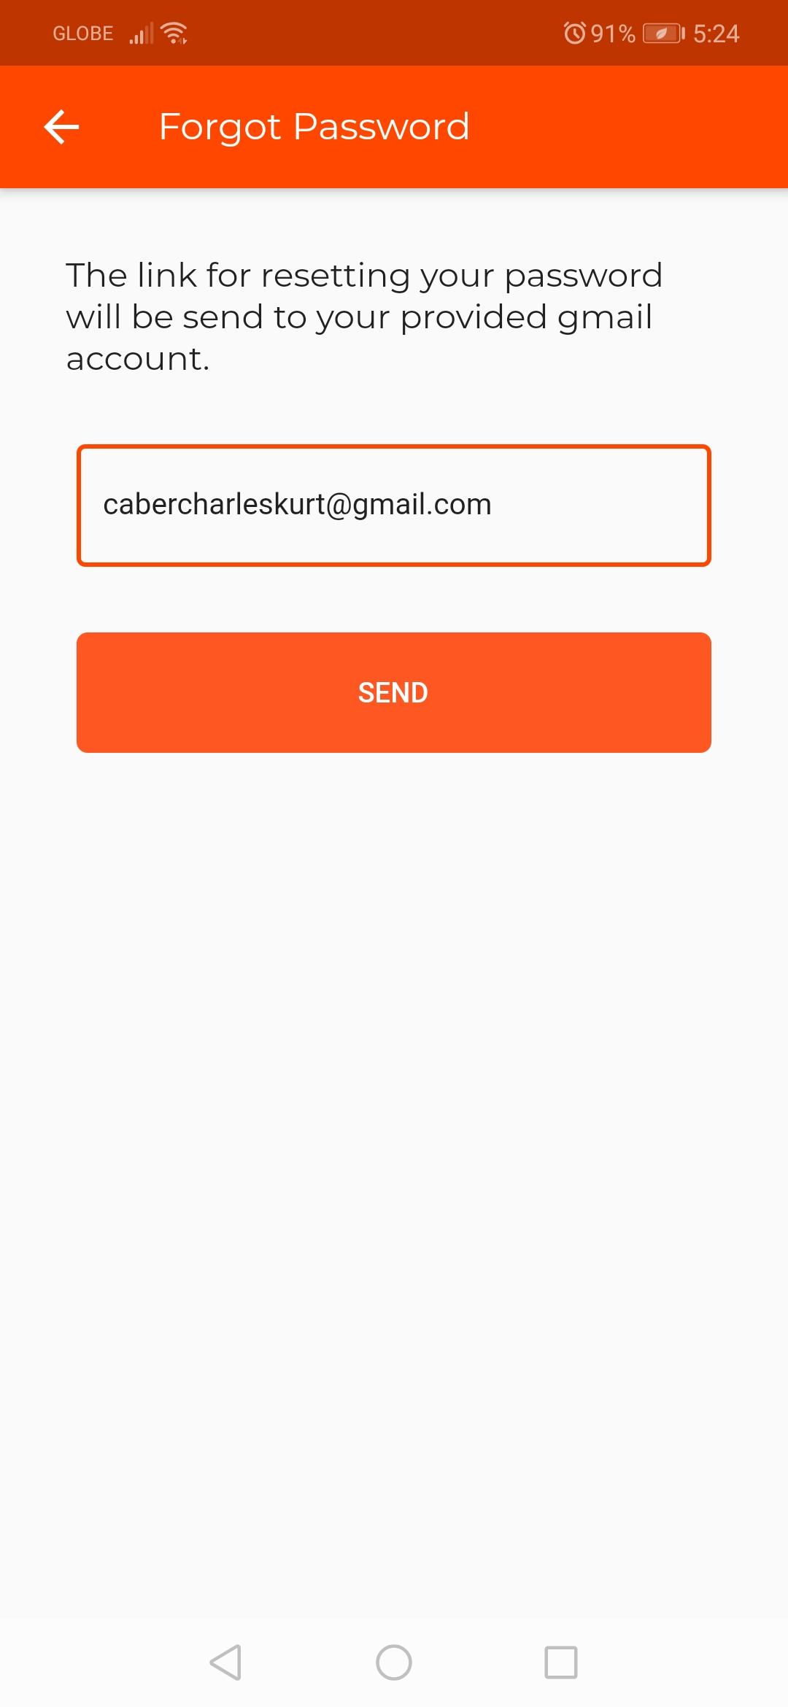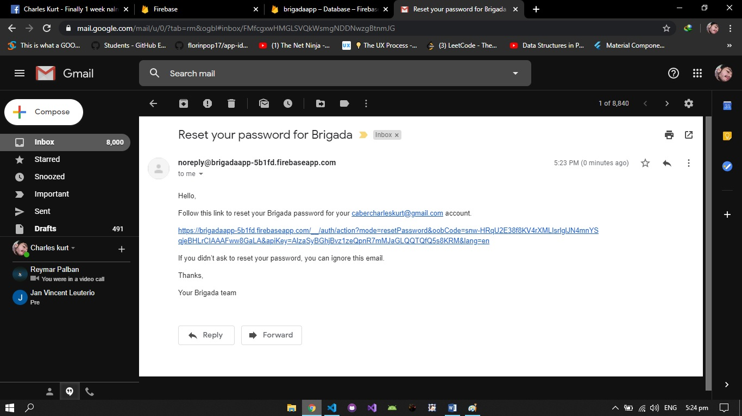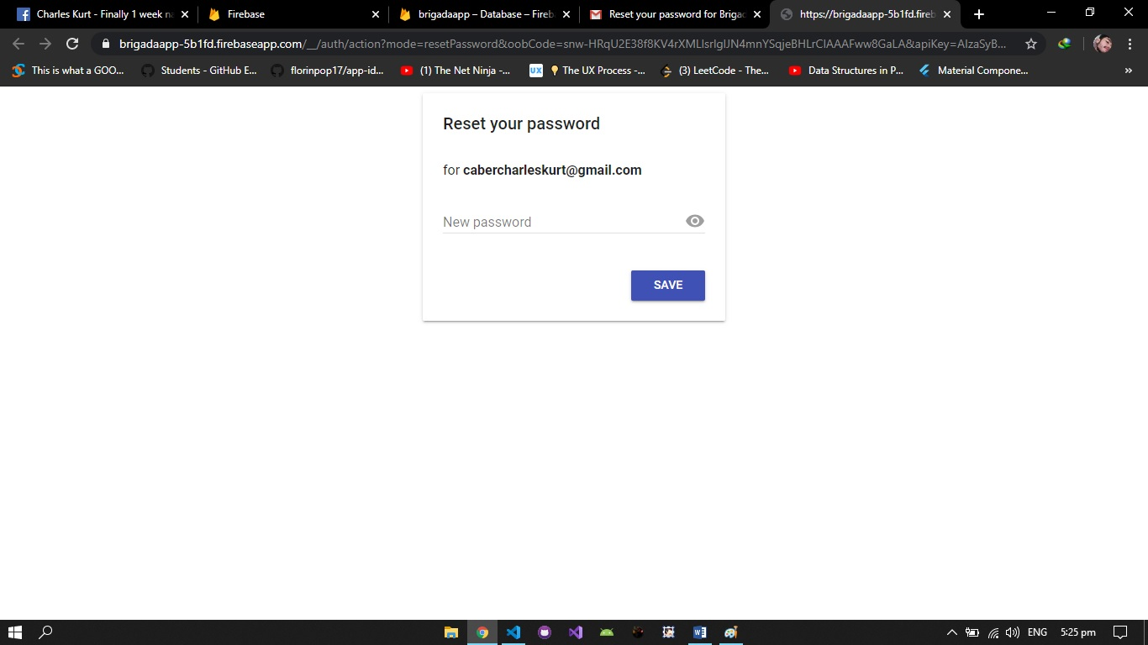

Last if Data is not found or already deleted the screen will show you this.

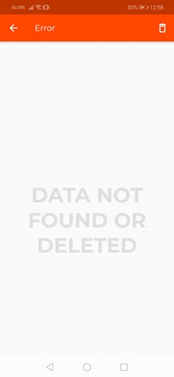

**You can delete that by clicking trash button**

THANK YOU.